**A Project Report  
ON   
BANK MANAGEMENT SYSTEM**

Submitted To: Submitted by: Mr. Sartaj Tanuj Rohilla

**IBM TRAINING CENTRE**

**ACKNOWLEDGEMENT**

We gratefully acknowledge for the assistance, cooperation, guidance and

clarifications provided by IBM during the development of the Online Examination

System Project. Our extreme gratitude to Mr. Sartaj who guided us

throughout the project. Without his willing disposition, spirit of accommodation,

frankness, timely clarification and above all faith in us, this project could not have

been completed in due time.

His readiness to discuss all important matters at work deserves special attention.

We would also like to thank whole of the faculty of the college for their

cooperation and important support.

**CERTIFICATE**

This is to certify that the project entitled **“Bank Management System”**  has been developed by **“Tanuj Rohilla”**.

He has worked on the project Online Exam System. He has used JAVA and MS.ACCESS as Database for the project. His work is satisfactory.

I wish him all the best for his bright future.

**Project Synopsis on Internet Banking System**

The main aim of designing and developing this banking System JAVA primarily based is to provide secure and efficient banking facilities to the banking customers . Java Swings, Java, Enterprise Beans, Oracle database used to develop this bank application where all banking customers can login through the secured web page by their account login id and password. Users will have all options and features in that application like get money from western union, money transfer to others, make payments for electricity bills, mobile prepaid recharges, mobile bills, water bills etc, and send cash or money to inter banking as well as other banking customers by simply adding them as payees.

**Project Introduction**

Bank Management System is very simple and entry level project developed in java using jdbc technology. I have used database to store all the details of customer account in a table. This system is a simple project and useful for those who want to learn jdbc.

I have implemented most of the feature of online banking in it. User can login, do withdrawal, Request a Deposit amount, Transfer amount from one account to another account, check his/her current balance, and view reports of all the transaction.

**Purpose**

The Online Banking suite provides a global accounting foundation that provides the all private banks with electronic banking facilities. It allows client of private banks to carry out their day to day banking transactions.

**Modules**

1. **Registration**
2. **Account Details**
3. **Deposit Cash**
4. **Withdraw Cash**
5. **Transfer Money**
6. **Transaction History**
7. **Close Account**

**Benefits of the System**

* Quick, simple, authenticated access to accounts via the desktop.
* Simply scalable to grow with changing system requirement.
* Global enterprise wide access to information.
* Improved data security, restricting unauthorized access.
* Minimize Storage Space

**Software Requirement**

* Operating System : Windows XP, Window 7, Window 8.1, etc
* Back End : MS-Access for Database, SQL Server
* Front End : JAVA using Swings
* Database Connectivity: JDBC, Microsoft ODBC
* Driver for Oracle

**Source Code**

**1. Opening Page**

package Bank_Management_System;

/**

*

* @author TANUJ ROHILLA

*/

public class first extends javax.swing.JFrame {

/**

* Creates new form first

*/

public first() {

initComponents();

}

/**

* This method is called from within the constructor to initialize the form.

* WARNING: Do NOT modify this code. The content of this method is always

* regenerated by the Form Editor.

*/

@SuppressWarnings("unchecked")

// <editor-fold defaultstate="collapsed" desc="Generated Code">

private void initComponents() {

jLabel1 = new javax.swing.JLabel();

jButton1 = new javax.swing.JButton();

jLabel2 = new javax.swing.JLabel();

jLabel3 = new javax.swing.JLabel();

jButton2 = new javax.swing.JButton();

setDefaultCloseOperation(javax.swing.WindowConstants.EXIT_ON_CLOSE);

setTitle("Bank Management System");

jLabel1.setFont(new java.awt.Font("Tahoma", 1, 24)); // NOI18N

jLabel1.setText("Bank Management System");

jButton1.setText("Login");

jButton1.addActionListener(new java.awt.event.ActionListener() {

public void actionPerformed(java.awt.event.ActionEvent evt) {

jButton1ActionPerformed(evt);

}

});

jLabel2.setText("1.");

jLabel3.setText("2.");

jButton2.setText("New Registration");

jButton2.addActionListener(new java.awt.event.ActionListener() {

public void actionPerformed(java.awt.event.ActionEvent evt) {

jButton2ActionPerformed(evt);

}

});

javax.swing.GroupLayout layout = new javax.swing.GroupLayout(getContentPane());

getContentPane().setLayout(layout);

layout.setHorizontalGroup(

layout.createParallelGroup(javax.swing.GroupLayout.Alignment.LEADING)

.addGroup(layout.createSequentialGroup()

.addContainerGap(158, Short.MAX_VALUE)

.addComponent(jLabel1)

.addGap(126, 126, 126))

.addGroup(layout.createSequentialGroup()

.addGap(212, 212, 212)

.addGroup(layout.createParallelGroup(javax.swing.GroupLayout.Alignment.LEADING)

.addGroup(layout.createSequentialGroup()

.addComponent(jLabel3)

.addGap(18, 18, 18)

.addComponent(jButton2))

.addGroup(layout.createSequentialGroup()

.addComponent(jLabel2)

.addGap(18, 18, 18)

.addComponent(jButton1)))

.addContainerGap(javax.swing.GroupLayout.DEFAULT_SIZE, Short.MAX_VALUE))

);

layout.setVerticalGroup(

layout.createParallelGroup(javax.swing.GroupLayout.Alignment.LEADING)

.addGroup(layout.createSequentialGroup()

.addGap(65, 65, 65)

.addComponent(jLabel1)

.addGap(72, 72, 72)

.addGroup(layout.createParallelGroup(javax.swing.GroupLayout.Alignment.TRAILING)

.addComponent(jButton1)

.addComponent(jLabel2))

.addGap(18, 18, 18)

.addGroup(layout.createParallelGroup(javax.swing.GroupLayout.Alignment.TRAILING)

.addComponent(jLabel3)

.addComponent(jButton2))

.addContainerGap(220, Short.MAX_VALUE))

);

pack();

}// </editor-fold>

private void jButton1ActionPerformed(java.awt.event.ActionEvent evt) {

// TODO add your handling code here:

this.setVisible(false);

Login_page l=new Login_page();

l.setVisible(true);

}

private void jButton2ActionPerformed(java.awt.event.ActionEvent evt) {

// TODO add your handling code here:

this.setVisible(false);

Registration_page r=new Registration_page();

r.setVisible(true);

}

/**

* @param args the command line arguments

*/

public static void main(String args[]) {

/* Set the Nimbus look and feel */

//<editor-fold defaultstate="collapsed" desc=" Look and feel setting code (optional) ">

/* If Nimbus (introduced in Java SE 6) is not available, stay with the default look and feel.

* For details see http://download.oracle.com/javase/tutorial/uiswing/lookandfeel/plaf.html

*/

try {

for (javax.swing.UIManager.LookAndFeelInfo info : javax.swing.UIManager.getInstalledLookAndFeels()) {

if ("Nimbus".equals(info.getName())) {

javax.swing.UIManager.setLookAndFeel(info.getClassName());

break;

}

}

} catch (ClassNotFoundException ex) {

java.util.logging.Logger.getLogger(first.class.getName()).log(java.util.logging.Level.SEVERE, null, ex);

} catch (InstantiationException ex) {

java.util.logging.Logger.getLogger(first.class.getName()).log(java.util.logging.Level.SEVERE, null, ex);

} catch (IllegalAccessException ex) {

java.util.logging.Logger.getLogger(first.class.getName()).log(java.util.logging.Level.SEVERE, null, ex);

} catch (javax.swing.UnsupportedLookAndFeelException ex) {

java.util.logging.Logger.getLogger(first.class.getName()).log(java.util.logging.Level.SEVERE, null, ex);

}

//</editor-fold>

/* Create and display the form */

java.awt.EventQueue.invokeLater(new Runnable() {

public void run() {

new first().setVisible(true);

}

});

}

// Variables declaration - do not modify

private javax.swing.JButton jButton1;

private javax.swing.JButton jButton2;

private javax.swing.JLabel jLabel1;

private javax.swing.JLabel jLabel2;

private javax.swing.JLabel jLabel3;

// End of variables declaration

}

**2. Login page**

package Bank_Management_System;

import java.sql.Connection;

import java.sql.DriverManager;

import java.sql.PreparedStatement;

import java.sql.ResultSet;

import javax.swing.JOptionPane;

/**

*

* @author TANUJ ROHILLA

*/

public class Login_page extends javax.swing.JFrame {

PreparedStatement ps;

ResultSet rs;

Connection con;

/**

* Creates new form Login_page

*/

public Login_page() {

initComponents();

}

/**

* This method is called from within the constructor to initialize the form.

* WARNING: Do NOT modify this code. The content of this method is always

* regenerated by the Form Editor.

*/

@SuppressWarnings("unchecked")

// <editor-fold defaultstate="collapsed" desc="Generated Code">

private void initComponents() {

jLabel1 = new javax.swing.JLabel();

jLabel2 = new javax.swing.JLabel();

jLabel3 = new javax.swing.JLabel();

jTextField1 = new javax.swing.JTextField();

jPasswordField1 = new javax.swing.JPasswordField();

jButton1 = new javax.swing.JButton();

jButton2 = new javax.swing.JButton();

setDefaultCloseOperation(javax.swing.WindowConstants.EXIT_ON_CLOSE);

setTitle("Bank Management System");

jLabel1.setFont(new java.awt.Font("Tahoma", 1, 24)); // NOI18N

jLabel1.setText("Login");

jLabel2.setText("Account Number");

jLabel3.setText("PIN");

jButton1.setFont(new java.awt.Font("Tahoma", 1, 11)); // NOI18N

jButton1.setText("Login");

jButton1.addActionListener(new java.awt.event.ActionListener() {

public void actionPerformed(java.awt.event.ActionEvent evt) {

jButton1ActionPerformed(evt);

}

});

jButton2.setFont(new java.awt.Font("Tahoma", 1, 11)); // NOI18N

jButton2.setText("New Registration");

jButton2.addActionListener(new java.awt.event.ActionListener() {

public void actionPerformed(java.awt.event.ActionEvent evt) {

jButton2ActionPerformed(evt);

}

});

javax.swing.GroupLayout layout = new javax.swing.GroupLayout(getContentPane());

getContentPane().setLayout(layout);

layout.setHorizontalGroup(

layout.createParallelGroup(javax.swing.GroupLayout.Alignment.LEADING)

.addGroup(layout.createSequentialGroup()

.addGroup(layout.createParallelGroup(javax.swing.GroupLayout.Alignment.LEADING)

.addGroup(layout.createSequentialGroup()

.addGap(136, 136, 136)

.addGroup(layout.createParallelGroup(javax.swing.GroupLayout.Alignment.LEADING)

.addComponent(jLabel2)

.addComponent(jLabel3))

.addGap(49, 49, 49)

.addGroup(layout.createParallelGroup(javax.swing.GroupLayout.Alignment.LEADING)

.addComponent(jTextField1, javax.swing.GroupLayout.PREFERRED_SIZE, 191, javax.swing.GroupLayout.PREFERRED_SIZE)

.addComponent(jPasswordField1, javax.swing.GroupLayout.PREFERRED_SIZE, 69, javax.swing.GroupLayout.PREFERRED_SIZE)))

.addGroup(layout.createSequentialGroup()

.addGap(245, 245, 245)

.addGroup(layout.createParallelGroup(javax.swing.GroupLayout.Alignment.LEADING)

.addComponent(jLabel1)

.addComponent(jButton1)))

.addGroup(javax.swing.GroupLayout.Alignment.TRAILING, layout.createSequentialGroup()

.addContainerGap()

.addComponent(jButton2)

.addGap(122, 122, 122)))

.addContainerGap(145, Short.MAX_VALUE))

);

layout.setVerticalGroup(

layout.createParallelGroup(javax.swing.GroupLayout.Alignment.LEADING)

.addGroup(layout.createSequentialGroup()

.addGap(70, 70, 70)

.addComponent(jLabel1)

.addGap(53, 53, 53)

.addGroup(layout.createParallelGroup(javax.swing.GroupLayout.Alignment.TRAILING)

.addComponent(jLabel2)

.addComponent(jTextField1, javax.swing.GroupLayout.PREFERRED_SIZE, javax.swing.GroupLayout.DEFAULT_SIZE, javax.swing.GroupLayout.PREFERRED_SIZE))

.addGap(18, 18, 18)

.addGroup(layout.createParallelGroup(javax.swing.GroupLayout.Alignment.BASELINE)

.addComponent(jLabel3)

.addComponent(jPasswordField1, javax.swing.GroupLayout.PREFERRED_SIZE, javax.swing.GroupLayout.DEFAULT_SIZE, javax.swing.GroupLayout.PREFERRED_SIZE))

.addGap(34, 34, 34)

.addComponent(jButton1)

.addGap(18, 18, 18)

.addComponent(jButton2)

.addContainerGap(142, Short.MAX_VALUE))

);

pack();

}// </editor-fold>

private void jButton1ActionPerformed(java.awt.event.ActionEvent evt) {

// TODO add your handling code here:

String pin,acc;

String data[]=new String[2];

try{

Class.forName("sun.jdbc.odbc.JdbcOdbcDriver");

con = DriverManager.getConnection("jdbc:odbc:ibm_project_db");

ps = con.prepareStatement("Select * from ibm_table2 where acc_no=?");

ps.setString(1,jTextField1.getText());

rs=ps.executeQuery();

rs.next();

pin=rs.getString("pin");

acc=rs.getString("acc_no");

if(pin.equals(jPasswordField1.getText())){

this.setVisible(false);

data[0]=acc;

menu.main(data);

}

}

catch(Exception e){

JOptionPane.showMessageDialog(null,e);

}

}

private void jButton2ActionPerformed(java.awt.event.ActionEvent evt) {

// TODO add your handling code here:

this.setVisible(false);

Registration_page r=new Registration_page();

r.setVisible(true);

}

/**

* @param args the command line arguments

*/

public static void main(String args[]) {

/* Set the Nimbus look and feel */

//<editor-fold defaultstate="collapsed" desc=" Look and feel setting code (optional) ">

/* If Nimbus (introduced in Java SE 6) is not available, stay with the default look and feel.

* For details see http://download.oracle.com/javase/tutorial/uiswing/lookandfeel/plaf.html

*/

try {

for (javax.swing.UIManager.LookAndFeelInfo info : javax.swing.UIManager.getInstalledLookAndFeels()) {

if ("Nimbus".equals(info.getName())) {

javax.swing.UIManager.setLookAndFeel(info.getClassName());

break;

}

}

} catch (ClassNotFoundException ex) {

java.util.logging.Logger.getLogger(Login_page.class.getName()).log(java.util.logging.Level.SEVERE, null, ex);

} catch (InstantiationException ex) {

java.util.logging.Logger.getLogger(Login_page.class.getName()).log(java.util.logging.Level.SEVERE, null, ex);

} catch (IllegalAccessException ex) {

java.util.logging.Logger.getLogger(Login_page.class.getName()).log(java.util.logging.Level.SEVERE, null, ex);

} catch (javax.swing.UnsupportedLookAndFeelException ex) {

java.util.logging.Logger.getLogger(Login_page.class.getName()).log(java.util.logging.Level.SEVERE, null, ex);

}

//</editor-fold>

/* Create and display the form */

java.awt.EventQueue.invokeLater(new Runnable() {

public void run() {

new Login_page().setVisible(true);

}

});

}

// Variables declaration - do not modify

private javax.swing.JButton jButton1;

private javax.swing.JButton jButton2;

private javax.swing.JLabel jLabel1;

private javax.swing.JLabel jLabel2;

private javax.swing.JLabel jLabel3;

private javax.swing.JPasswordField jPasswordField1;

private javax.swing.JTextField jTextField1;

// End of variables declaration

}

**3. Registration page**

package Bank_Management_System;

import com.sun.corba.se.impl.orbutil.ORBUtility;

import java.sql.Connection;

import javax.swing.*;

import java.sql.DriverManager;

import java.sql.PreparedStatement;

import java.sql.ResultSet;

import javax.swing.JOptionPane;

/**

*

* @author TANUJ ROHILLA

*/

public class Registration_page extends javax.swing.JFrame {

Connection con;

ResultSet rs;

PreparedStatement ps;

/**

* Creates new form Registration_page

*/

public Registration_page() {

initComponents();

}

/**

* This method is called from within the constructor to initialize the form.

* WARNING: Do NOT modify this code. The content of this method is always

* regenerated by the Form Editor.

*/

@SuppressWarnings("unchecked")

// <editor-fold defaultstate="collapsed" desc="Generated Code">

private void initComponents() {

jLabel1 = new javax.swing.JLabel();

jLabel2 = new javax.swing.JLabel();

jTextField1 = new javax.swing.JTextField();

jLabel3 = new javax.swing.JLabel();

jRadioButton1 = new javax.swing.JRadioButton();

jRadioButton2 = new javax.swing.JRadioButton();

jLabel4 = new javax.swing.JLabel();

jTextField2 = new javax.swing.JTextField();

jLabel5 = new javax.swing.JLabel();

jPasswordField1 = new javax.swing.JPasswordField();

jLabel6 = new javax.swing.JLabel();

jRadioButton3 = new javax.swing.JRadioButton();

jRadioButton4 = new javax.swing.JRadioButton();

jLabel8 = new javax.swing.JLabel();

jTextField3 = new javax.swing.JTextField();

jLabel9 = new javax.swing.JLabel();

jTextField4 = new javax.swing.JTextField();

jButton1 = new javax.swing.JButton();

jLabel7 = new javax.swing.JLabel();

jScrollPane1 = new javax.swing.JScrollPane();

jTextArea1 = new javax.swing.JTextArea();

setDefaultCloseOperation(javax.swing.WindowConstants.EXIT_ON_CLOSE);

setTitle("New Registration");

jLabel1.setFont(new java.awt.Font("Tahoma", 1, 24)); // NOI18N

jLabel1.setText("New Registration");

jLabel2.setText("Name ");

jLabel3.setText("Gender");

jRadioButton1.setText("Male");

jRadioButton1.addActionListener(new java.awt.event.ActionListener() {

public void actionPerformed(java.awt.event.ActionEvent evt) {

jRadioButton1ActionPerformed(evt);

}

});

jRadioButton2.setText("Female");

jRadioButton2.addActionListener(new java.awt.event.ActionListener() {

public void actionPerformed(java.awt.event.ActionEvent evt) {

jRadioButton2ActionPerformed(evt);

}

});

jLabel4.setText("Account number");

jLabel5.setText("PIN");

jLabel6.setText("Account Type");

jRadioButton3.setText("Saving");

jRadioButton3.addActionListener(new java.awt.event.ActionListener() {

public void actionPerformed(java.awt.event.ActionEvent evt) {

jRadioButton3ActionPerformed(evt);

}

});

jRadioButton4.setText("Current");

jRadioButton4.addActionListener(new java.awt.event.ActionListener() {

public void actionPerformed(java.awt.event.ActionEvent evt) {

jRadioButton4ActionPerformed(evt);

}

});

jLabel8.setText("Email id");

jLabel9.setText("Contact no.");

jButton1.setText("Register");

jButton1.addActionListener(new java.awt.event.ActionListener() {

public void actionPerformed(java.awt.event.ActionEvent evt) {

jButton1ActionPerformed(evt);

}

});

jLabel7.setText("Address");

jTextArea1.setColumns(20);

jTextArea1.setRows(5);

jScrollPane1.setViewportView(jTextArea1);

javax.swing.GroupLayout layout = new javax.swing.GroupLayout(getContentPane());

getContentPane().setLayout(layout);

layout.setHorizontalGroup(

layout.createParallelGroup(javax.swing.GroupLayout.Alignment.LEADING)

.addGroup(layout.createSequentialGroup()

.addGroup(layout.createParallelGroup(javax.swing.GroupLayout.Alignment.LEADING)

.addGroup(layout.createSequentialGroup()

.addGap(121, 121, 121)

.addGroup(layout.createParallelGroup(javax.swing.GroupLayout.Alignment.LEADING)

.addGroup(layout.createSequentialGroup()

.addGroup(layout.createParallelGroup(javax.swing.GroupLayout.Alignment.LEADING)

.addComponent(jLabel2)

.addComponent(jLabel3))

.addGap(36, 36, 36)

.addComponent(jLabel1))

.addGroup(layout.createSequentialGroup()

.addGroup(layout.createParallelGroup(javax.swing.GroupLayout.Alignment.LEADING)

.addComponent(jLabel4)

.addComponent(jLabel5)

.addComponent(jLabel6)

.addComponent(jLabel9)

.addComponent(jLabel8)

.addComponent(jLabel7))

.addGap(35, 35, 35)

.addGroup(layout.createParallelGroup(javax.swing.GroupLayout.Alignment.LEADING, false)

.addGroup(layout.createSequentialGroup()

.addComponent(jRadioButton3)

.addGap(38, 38, 38)

.addComponent(jRadioButton4))

.addComponent(jTextField2)

.addGroup(layout.createSequentialGroup()

.addComponent(jRadioButton1)

.addPreferredGap(javax.swing.LayoutStyle.ComponentPlacement.RELATED, javax.swing.GroupLayout.DEFAULT_SIZE, Short.MAX_VALUE)

.addComponent(jRadioButton2))

.addComponent(jTextField1)

.addComponent(jPasswordField1, javax.swing.GroupLayout.PREFERRED_SIZE, 66, javax.swing.GroupLayout.PREFERRED_SIZE)

.addComponent(jTextField3)

.addComponent(jTextField4)

.addComponent(jScrollPane1, javax.swing.GroupLayout.PREFERRED_SIZE, javax.swing.GroupLayout.DEFAULT_SIZE, javax.swing.GroupLayout.PREFERRED_SIZE)))))

.addGroup(layout.createSequentialGroup()

.addGap(244, 244, 244)

.addComponent(jButton1)))

.addContainerGap(260, Short.MAX_VALUE))

);

layout.setVerticalGroup(

layout.createParallelGroup(javax.swing.GroupLayout.Alignment.LEADING)

.addGroup(layout.createSequentialGroup()

.addGap(33, 33, 33)

.addComponent(jLabel1)

.addGap(23, 23, 23)

.addGroup(layout.createParallelGroup(javax.swing.GroupLayout.Alignment.BASELINE)

.addComponent(jLabel2)

.addComponent(jTextField1, javax.swing.GroupLayout.PREFERRED_SIZE, javax.swing.GroupLayout.DEFAULT_SIZE, javax.swing.GroupLayout.PREFERRED_SIZE))

.addGap(18, 18, 18)

.addGroup(layout.createParallelGroup(javax.swing.GroupLayout.Alignment.LEADING)

.addComponent(jLabel3)

.addGroup(layout.createParallelGroup(javax.swing.GroupLayout.Alignment.BASELINE)

.addComponent(jRadioButton1)

.addComponent(jRadioButton2)))

.addGap(18, 18, 18)

.addGroup(layout.createParallelGroup(javax.swing.GroupLayout.Alignment.BASELINE)

.addComponent(jTextField2, javax.swing.GroupLayout.PREFERRED_SIZE, javax.swing.GroupLayout.DEFAULT_SIZE, javax.swing.GroupLayout.PREFERRED_SIZE)

.addComponent(jLabel4))

.addGap(18, 18, 18)

.addGroup(layout.createParallelGroup(javax.swing.GroupLayout.Alignment.TRAILING)

.addComponent(jLabel5)

.addComponent(jPasswordField1, javax.swing.GroupLayout.PREFERRED_SIZE, javax.swing.GroupLayout.DEFAULT_SIZE, javax.swing.GroupLayout.PREFERRED_SIZE))

.addGap(18, 18, 18)

.addGroup(layout.createParallelGroup(javax.swing.GroupLayout.Alignment.BASELINE)

.addComponent(jLabel6)

.addComponent(jRadioButton3)

.addComponent(jRadioButton4))

.addGroup(layout.createParallelGroup(javax.swing.GroupLayout.Alignment.LEADING)

.addGroup(layout.createSequentialGroup()

.addGap(28, 28, 28)

.addComponent(jLabel8))

.addGroup(layout.createSequentialGroup()

.addGap(18, 18, 18)

.addComponent(jTextField3, javax.swing.GroupLayout.PREFERRED_SIZE, javax.swing.GroupLayout.DEFAULT_SIZE, javax.swing.GroupLayout.PREFERRED_SIZE)))

.addGap(26, 26, 26)

.addGroup(layout.createParallelGroup(javax.swing.GroupLayout.Alignment.BASELINE)

.addComponent(jLabel9)

.addComponent(jTextField4, javax.swing.GroupLayout.PREFERRED_SIZE, javax.swing.GroupLayout.DEFAULT_SIZE, javax.swing.GroupLayout.PREFERRED_SIZE))

.addGroup(layout.createParallelGroup(javax.swing.GroupLayout.Alignment.LEADING)

.addGroup(layout.createSequentialGroup()

.addGap(30, 30, 30)

.addComponent(jLabel7)

.addPreferredGap(javax.swing.LayoutStyle.ComponentPlacement.RELATED, javax.swing.GroupLayout.DEFAULT_SIZE, Short.MAX_VALUE))

.addGroup(javax.swing.GroupLayout.Alignment.TRAILING, layout.createSequentialGroup()

.addPreferredGap(javax.swing.LayoutStyle.ComponentPlacement.RELATED, 20, Short.MAX_VALUE)

.addComponent(jScrollPane1, javax.swing.GroupLayout.PREFERRED_SIZE, javax.swing.GroupLayout.DEFAULT_SIZE, javax.swing.GroupLayout.PREFERRED_SIZE)

.addGap(18, 18, 18)))

.addComponent(jButton1)

.addContainerGap())

);

pack();

}// </editor-fold>

private void jButton1ActionPerformed(java.awt.event.ActionEvent evt) {

// TODO add your handling code here:

try{

Class.forName("sun.jdbc.odbc.JdbcOdbcDriver");

con = DriverManager.getConnection("jdbc:odbc:ibm_project_db");

ps = con.prepareStatement("Insert into ibm_table2 values (?,?,?,?,?,0,?,?,?)");

ps.setString(1,jTextField2.getText());

ps.setInt(2,Integer.parseInt(jPasswordField1.getText()));

ps.setString(3,jTextField1.getText());

if(jRadioButton1.isSelected()){

ps.setString(4,jRadioButton1.getText());

}

else if(jRadioButton2.isSelected()){

ps.setString(4,jRadioButton2.getText());

}

if(jRadioButton3.isSelected()){

ps.setString(5, jRadioButton3.getText());

}

else if(jRadioButton4.isSelected()){

ps.setString(5, jRadioButton4.getText());

}

ps.setString(6,jTextField3.getText());

ps.setString(7,jTextField4.getText());

ps.setString(8,jTextArea1.getText());

ps.executeUpdate();

JOptionPane.showMessageDialog(null,"Successfully Registered");

con.close();

this.setVisible(false);

first l=new first();

l.setVisible(true);

}

catch(Exception e){

JOptionPane.showMessageDialog(null, e);

}

}

private void jRadioButton1ActionPerformed(java.awt.event.ActionEvent evt) {

// TODO add your handling code here:

jRadioButton2.setSelected(false);

}

private void jRadioButton2ActionPerformed(java.awt.event.ActionEvent evt) {

// TODO add your handling code here:

jRadioButton1.setSelected(false);

}

private void jRadioButton3ActionPerformed(java.awt.event.ActionEvent evt) {

// TODO add your handling code here:

jRadioButton4.setSelected(false);

}

private void jRadioButton4ActionPerformed(java.awt.event.ActionEvent evt) {

// TODO add your handling code here:

jRadioButton3.setSelected(false);

}

/**

* @param args the command line arguments

*/

public static void main(String args[]) {

/* Set the Nimbus look and feel */

//<editor-fold defaultstate="collapsed" desc=" Look and feel setting code (optional) ">

/* If Nimbus (introduced in Java SE 6) is not available, stay with the default look and feel.

* For details see http://download.oracle.com/javase/tutorial/uiswing/lookandfeel/plaf.html

*/

try {

for (javax.swing.UIManager.LookAndFeelInfo info : javax.swing.UIManager.getInstalledLookAndFeels()) {

if ("Nimbus".equals(info.getName())) {

javax.swing.UIManager.setLookAndFeel(info.getClassName());

break;

}

}

} catch (ClassNotFoundException ex) {

java.util.logging.Logger.getLogger(Registration_page.class.getName()).log(java.util.logging.Level.SEVERE, null, ex);

} catch (InstantiationException ex) {

java.util.logging.Logger.getLogger(Registration_page.class.getName()).log(java.util.logging.Level.SEVERE, null, ex);

} catch (IllegalAccessException ex) {

java.util.logging.Logger.getLogger(Registration_page.class.getName()).log(java.util.logging.Level.SEVERE, null, ex);

} catch (javax.swing.UnsupportedLookAndFeelException ex) {

java.util.logging.Logger.getLogger(Registration_page.class.getName()).log(java.util.logging.Level.SEVERE, null, ex);

}

//</editor-fold>

/* Create and display the form */

java.awt.EventQueue.invokeLater(new Runnable() {

public void run() {

new Registration_page().setVisible(true);

}

});

}

// Variables declaration - do not modify

private javax.swing.JButton jButton1;

private javax.swing.JLabel jLabel1;

private javax.swing.JLabel jLabel2;

private javax.swing.JLabel jLabel3;

private javax.swing.JLabel jLabel4;

private javax.swing.JLabel jLabel5;

private javax.swing.JLabel jLabel6;

private javax.swing.JLabel jLabel7;

private javax.swing.JLabel jLabel8;

private javax.swing.JLabel jLabel9;

private javax.swing.JPasswordField jPasswordField1;

private javax.swing.JRadioButton jRadioButton1;

private javax.swing.JRadioButton jRadioButton2;

private javax.swing.JRadioButton jRadioButton3;

private javax.swing.JRadioButton jRadioButton4;

private javax.swing.JScrollPane jScrollPane1;

private javax.swing.JTextArea jTextArea1;

private javax.swing.JTextField jTextField1;

private javax.swing.JTextField jTextField2;

private javax.swing.JTextField jTextField3;

private javax.swing.JTextField jTextField4;

// End of variables declaration

}

**4. Menu**

package Bank_Management_System;

import java.sql.Connection;

import java.sql.PreparedStatement;

import java.sql.ResultSet;

/**

*

* @author TANUJ ROHILLA

*/

public class menu extends javax.swing.JFrame {

static String data[]=new String[1];

PreparedStatement ps;

ResultSet rs;

Connection con;

/**

* Creates new form menu

*/

public menu() {

initComponents();

}

/**

* This method is called from within the constructor to initialize the form.

* WARNING: Do NOT modify this code. The content of this method is always

* regenerated by the Form Editor.

*/

@SuppressWarnings("unchecked")

// <editor-fold defaultstate="collapsed" desc="Generated Code">

private void initComponents() {

jLabel1 = new javax.swing.JLabel();

jLabel2 = new javax.swing.JLabel();

jButton1 = new javax.swing.JButton();

jLabel3 = new javax.swing.JLabel();

jButton2 = new javax.swing.JButton();

jLabel4 = new javax.swing.JLabel();

jButton3 = new javax.swing.JButton();

jLabel5 = new javax.swing.JLabel();

jButton4 = new javax.swing.JButton();

jLabel6 = new javax.swing.JLabel();

jButton5 = new javax.swing.JButton();

jButton6 = new javax.swing.JButton();

jLabel7 = new javax.swing.JLabel();

jButton7 = new javax.swing.JButton();

setDefaultCloseOperation(javax.swing.WindowConstants.EXIT_ON_CLOSE);

setTitle("Menu");

jLabel1.setFont(new java.awt.Font("Tahoma", 1, 24)); // NOI18N

jLabel1.setText("Welcome");

jLabel2.setText("1.");

jButton1.setText("Deposit Amount");

jButton1.addActionListener(new java.awt.event.ActionListener() {

public void actionPerformed(java.awt.event.ActionEvent evt) {

jButton1ActionPerformed(evt);

}

});

jLabel3.setText("2.");

jButton2.setText("Withdraw Amount");

jButton2.addActionListener(new java.awt.event.ActionListener() {

public void actionPerformed(java.awt.event.ActionEvent evt) {

jButton2ActionPerformed(evt);

}

});

jLabel4.setText("3.");

jButton3.setText("Check Balance");

jButton3.addActionListener(new java.awt.event.ActionListener() {

public void actionPerformed(java.awt.event.ActionEvent evt) {

jButton3ActionPerformed(evt);

}

});

jLabel5.setText("4.");

jButton4.setText("Modify Account");

jButton4.addActionListener(new java.awt.event.ActionListener() {

public void actionPerformed(java.awt.event.ActionEvent evt) {

jButton4ActionPerformed(evt);

}

});

jLabel6.setText("5.");

jButton5.setText("Close An Account");

jButton5.addActionListener(new java.awt.event.ActionListener() {

public void actionPerformed(java.awt.event.ActionEvent evt) {

jButton5ActionPerformed(evt);

}

});

jButton6.setFont(new java.awt.Font("Tahoma", 1, 11)); // NOI18N

jButton6.setText("Sign Out");

jButton6.addActionListener(new java.awt.event.ActionListener() {

public void actionPerformed(java.awt.event.ActionEvent evt) {

jButton6ActionPerformed(evt);

}

});

jLabel7.setText("6.");

jButton7.setText("Transfer Money");

jButton7.addActionListener(new java.awt.event.ActionListener() {

public void actionPerformed(java.awt.event.ActionEvent evt) {

jButton7ActionPerformed(evt);

}

});

javax.swing.GroupLayout layout = new javax.swing.GroupLayout(getContentPane());

getContentPane().setLayout(layout);

layout.setHorizontalGroup(

layout.createParallelGroup(javax.swing.GroupLayout.Alignment.LEADING)

.addGroup(layout.createSequentialGroup()

.addGroup(layout.createParallelGroup(javax.swing.GroupLayout.Alignment.LEADING)

.addGroup(layout.createSequentialGroup()

.addGap(259, 259, 259)

.addComponent(jLabel1))

.addGroup(layout.createSequentialGroup()

.addGap(129, 129, 129)

.addGroup(layout.createParallelGroup(javax.swing.GroupLayout.Alignment.LEADING)

.addGroup(layout.createParallelGroup(javax.swing.GroupLayout.Alignment.LEADING, false)

.addGroup(layout.createSequentialGroup()

.addComponent(jLabel5)

.addPreferredGap(javax.swing.LayoutStyle.ComponentPlacement.UNRELATED)

.addComponent(jButton4, javax.swing.GroupLayout.DEFAULT_SIZE, javax.swing.GroupLayout.DEFAULT_SIZE, Short.MAX_VALUE))

.addGroup(layout.createSequentialGroup()

.addComponent(jLabel4)

.addPreferredGap(javax.swing.LayoutStyle.ComponentPlacement.UNRELATED)

.addComponent(jButton3, javax.swing.GroupLayout.DEFAULT_SIZE, javax.swing.GroupLayout.DEFAULT_SIZE, Short.MAX_VALUE))

.addGroup(layout.createSequentialGroup()

.addComponent(jLabel3)

.addPreferredGap(javax.swing.LayoutStyle.ComponentPlacement.UNRELATED)

.addComponent(jButton2))

.addGroup(layout.createSequentialGroup()

.addComponent(jLabel2)

.addPreferredGap(javax.swing.LayoutStyle.ComponentPlacement.UNRELATED)

.addComponent(jButton1, javax.swing.GroupLayout.DEFAULT_SIZE, javax.swing.GroupLayout.DEFAULT_SIZE, Short.MAX_VALUE)))

.addGroup(layout.createParallelGroup(javax.swing.GroupLayout.Alignment.TRAILING, false)

.addGroup(javax.swing.GroupLayout.Alignment.LEADING, layout.createSequentialGroup()

.addComponent(jLabel7)

.addPreferredGap(javax.swing.LayoutStyle.ComponentPlacement.UNRELATED)

.addComponent(jButton7, javax.swing.GroupLayout.DEFAULT_SIZE, javax.swing.GroupLayout.DEFAULT_SIZE, Short.MAX_VALUE))

.addGroup(layout.createSequentialGroup()

.addComponent(jLabel6)

.addPreferredGap(javax.swing.LayoutStyle.ComponentPlacement.UNRELATED)

.addComponent(jButton5))))))

.addContainerGap(230, Short.MAX_VALUE))

.addGroup(javax.swing.GroupLayout.Alignment.TRAILING, layout.createSequentialGroup()

.addGap(0, 0, Short.MAX_VALUE)

.addComponent(jButton6)

.addGap(253, 253, 253))

);

layout.setVerticalGroup(

layout.createParallelGroup(javax.swing.GroupLayout.Alignment.LEADING)

.addGroup(layout.createSequentialGroup()

.addGap(47, 47, 47)

.addGroup(layout.createParallelGroup(javax.swing.GroupLayout.Alignment.TRAILING)

.addComponent(jButton1)

.addGroup(layout.createSequentialGroup()

.addComponent(jLabel1)

.addGap(41, 41, 41)

.addComponent(jLabel2)))

.addGap(18, 18, 18)

.addGroup(layout.createParallelGroup(javax.swing.GroupLayout.Alignment.TRAILING)

.addComponent(jLabel3)

.addComponent(jButton2))

.addGap(18, 18, 18)

.addGroup(layout.createParallelGroup(javax.swing.GroupLayout.Alignment.TRAILING)

.addComponent(jLabel4)

.addComponent(jButton3))

.addGap(18, 18, 18)

.addGroup(layout.createParallelGroup(javax.swing.GroupLayout.Alignment.TRAILING)

.addComponent(jLabel5)

.addComponent(jButton4))

.addGap(18, 18, 18)

.addGroup(layout.createParallelGroup(javax.swing.GroupLayout.Alignment.TRAILING)

.addComponent(jLabel6)

.addComponent(jButton5))

.addGap(18, 18, 18)

.addGroup(layout.createParallelGroup(javax.swing.GroupLayout.Alignment.TRAILING)

.addComponent(jButton7)

.addComponent(jLabel7))

.addPreferredGap(javax.swing.LayoutStyle.ComponentPlacement.RELATED, 33, Short.MAX_VALUE)

.addComponent(jButton6)

.addGap(58, 58, 58))

);

pack();

}// </editor-fold>

private void jButton1ActionPerformed(java.awt.event.ActionEvent evt) {

// TODO add your handling code here:

this.setVisible(false);

deposit.main(data);

}

private void jButton2ActionPerformed(java.awt.event.ActionEvent evt) {

// TODO add your handling code here:

this.setVisible(false);

withdraw.main(data);

}

private void jButton3ActionPerformed(java.awt.event.ActionEvent evt) {

// TODO add your handling code here:

this.setVisible(false);

balance.main(data);

}

private void jButton4ActionPerformed(java.awt.event.ActionEvent evt) {

// TODO add your handling code here:

this.setVisible(false);

modify.main(data);

}

private void jButton5ActionPerformed(java.awt.event.ActionEvent evt) {

// TODO add your handling code here:

this.setVisible(false);

closing.main(data);

}

private void jButton7ActionPerformed(java.awt.event.ActionEvent evt) {

// TODO add your handling code here:

this.setVisible(false);

transfer.main(data);

}

private void jButton6ActionPerformed(java.awt.event.ActionEvent evt) {

// TODO add your handling code here:

this.setVisible(false);

Login_page l=new Login_page();

l.setVisible(true);

}

/**

* @param args the command line arguments

*/

public static void main(String args[]) {

/* Set the Nimbus look and feel */

//<editor-fold defaultstate="collapsed" desc=" Look and feel setting code (optional) ">

/* If Nimbus (introduced in Java SE 6) is not available, stay with the default look and feel.

* For details see http://download.oracle.com/javase/tutorial/uiswing/lookandfeel/plaf.html

*/

try {

for (javax.swing.UIManager.LookAndFeelInfo info : javax.swing.UIManager.getInstalledLookAndFeels()) {

if ("Nimbus".equals(info.getName())) {

javax.swing.UIManager.setLookAndFeel(info.getClassName());

break;

}

}

} catch (ClassNotFoundException ex) {

java.util.logging.Logger.getLogger(menu.class.getName()).log(java.util.logging.Level.SEVERE, null, ex);

} catch (InstantiationException ex) {

java.util.logging.Logger.getLogger(menu.class.getName()).log(java.util.logging.Level.SEVERE, null, ex);

} catch (IllegalAccessException ex) {

java.util.logging.Logger.getLogger(menu.class.getName()).log(java.util.logging.Level.SEVERE, null, ex);

} catch (javax.swing.UnsupportedLookAndFeelException ex) {

java.util.logging.Logger.getLogger(menu.class.getName()).log(java.util.logging.Level.SEVERE, null, ex);

}

//</editor-fold>

data[0]=args[0];

/* Create and display the form */

java.awt.EventQueue.invokeLater(new Runnable() {

public void run() {

new menu().setVisible(true);

}

});

}

// Variables declaration - do not modify

private javax.swing.JButton jButton1;

private javax.swing.JButton jButton2;

private javax.swing.JButton jButton3;

private javax.swing.JButton jButton4;

private javax.swing.JButton jButton5;

private javax.swing.JButton jButton6;

private javax.swing.JButton jButton7;

private javax.swing.JLabel jLabel1;

private javax.swing.JLabel jLabel2;

private javax.swing.JLabel jLabel3;

private javax.swing.JLabel jLabel4;

private javax.swing.JLabel jLabel5;

private javax.swing.JLabel jLabel6;

private javax.swing.JLabel jLabel7;

// End of variables declaration

}

**5. Deposit Amount**

package Bank_Management_System;

import java.sql.Connection;

import java.sql.DriverManager;

import java.sql.PreparedStatement;

import java.sql.ResultSet;

import javax.swing.JOptionPane;

/**

*

* @author TANUJ ROHILLA

*/

public class deposit extends javax.swing.JFrame {

static String data[]=new String[1];

PreparedStatement ps,ps1;

ResultSet rs;

Connection con;

/**

* Creates new form deposit

*/

public deposit() {

initComponents();

}

/**

* This method is called from within the constructor to initialize the form.

* WARNING: Do NOT modify this code. The content of this method is always

* regenerated by the Form Editor.

*/

@SuppressWarnings("unchecked")

// <editor-fold defaultstate="collapsed" desc="Generated Code">

private void initComponents() {

jLabel1 = new javax.swing.JLabel();

jLabel2 = new javax.swing.JLabel();

jTextField1 = new javax.swing.JTextField();

jButton1 = new javax.swing.JButton();

setDefaultCloseOperation(javax.swing.WindowConstants.EXIT_ON_CLOSE);

setTitle("Deposit Amount");

jLabel1.setFont(new java.awt.Font("Tahoma", 1, 24)); // NOI18N

jLabel1.setText("Deposit Amount");

jLabel2.setText("Enter the amount do you wanted to deposit");

jButton1.setFont(new java.awt.Font("Tahoma", 1, 11)); // NOI18N

jButton1.setText("Deposit");

jButton1.addActionListener(new java.awt.event.ActionListener() {

public void actionPerformed(java.awt.event.ActionEvent evt) {

jButton1ActionPerformed(evt);

}

});

javax.swing.GroupLayout layout = new javax.swing.GroupLayout(getContentPane());

getContentPane().setLayout(layout);

layout.setHorizontalGroup(

layout.createParallelGroup(javax.swing.GroupLayout.Alignment.LEADING)

.addGroup(layout.createSequentialGroup()

.addGap(94, 94, 94)

.addComponent(jLabel2)

.addGap(63, 63, 63)

.addComponent(jTextField1, javax.swing.GroupLayout.PREFERRED_SIZE, 115, javax.swing.GroupLayout.PREFERRED_SIZE)

.addContainerGap(118, Short.MAX_VALUE))

.addGroup(javax.swing.GroupLayout.Alignment.TRAILING, layout.createSequentialGroup()

.addContainerGap(javax.swing.GroupLayout.DEFAULT_SIZE, Short.MAX_VALUE)

.addGroup(layout.createParallelGroup(javax.swing.GroupLayout.Alignment.LEADING)

.addGroup(javax.swing.GroupLayout.Alignment.TRAILING, layout.createSequentialGroup()

.addComponent(jLabel1)

.addGap(189, 189, 189))

.addGroup(javax.swing.GroupLayout.Alignment.TRAILING, layout.createSequentialGroup()

.addComponent(jButton1)

.addGap(254, 254, 254))))

);

layout.setVerticalGroup(

layout.createParallelGroup(javax.swing.GroupLayout.Alignment.LEADING)

.addGroup(layout.createSequentialGroup()

.addGap(64, 64, 64)

.addComponent(jLabel1)

.addGap(39, 39, 39)

.addGroup(layout.createParallelGroup(javax.swing.GroupLayout.Alignment.TRAILING)

.addComponent(jLabel2)

.addComponent(jTextField1, javax.swing.GroupLayout.PREFERRED_SIZE, javax.swing.GroupLayout.DEFAULT_SIZE, javax.swing.GroupLayout.PREFERRED_SIZE))

.addGap(91, 91, 91)

.addComponent(jButton1)

.addContainerGap(184, Short.MAX_VALUE))

);

pack();

}// </editor-fold>

private void jButton1ActionPerformed(java.awt.event.ActionEvent evt) {

// TODO add your handling code here:

int bal;

try{

Class.forName("sun.jdbc.odbc.JdbcOdbcDriver");

con = DriverManager.getConnection("jdbc:odbc:ibm_project_db");

ps = con.prepareStatement("Select * from ibm_table2 where acc_no=?");

//JOptionPane.showMessageDialog(null,data[0]);

ps.setString(1,data[0]);

rs=ps.executeQuery();

rs.next();

bal=rs.getInt("balance");

bal=bal+Integer.parseInt(jTextField1.getText());

ps1=con.prepareStatement("Update ibm_table2 set balance=? where acc_no=?");

ps1.setInt(1, bal);

ps1.setString(2, data[0]);

ps1.executeUpdate();

JOptionPane.showMessageDialog(null, "Successfully Deposit");

this.setVisible(false);

menu m =new menu();

m.setVisible(true);

}

catch(Exception e)

{

JOptionPane.showMessageDialog(null, e);

}

}

/**

* @param args the command line arguments

*/

public static void main(String args[]) {

/* Set the Nimbus look and feel */

//<editor-fold defaultstate="collapsed" desc=" Look and feel setting code (optional) ">

/* If Nimbus (introduced in Java SE 6) is not available, stay with the default look and feel.

* For details see http://download.oracle.com/javase/tutorial/uiswing/lookandfeel/plaf.html

*/

try {

for (javax.swing.UIManager.LookAndFeelInfo info : javax.swing.UIManager.getInstalledLookAndFeels()) {

if ("Nimbus".equals(info.getName())) {

javax.swing.UIManager.setLookAndFeel(info.getClassName());

break;

}

}

} catch (ClassNotFoundException ex) {

java.util.logging.Logger.getLogger(deposit.class.getName()).log(java.util.logging.Level.SEVERE, null, ex);

} catch (InstantiationException ex) {

java.util.logging.Logger.getLogger(deposit.class.getName()).log(java.util.logging.Level.SEVERE, null, ex);

} catch (IllegalAccessException ex) {

java.util.logging.Logger.getLogger(deposit.class.getName()).log(java.util.logging.Level.SEVERE, null, ex);

} catch (javax.swing.UnsupportedLookAndFeelException ex) {

java.util.logging.Logger.getLogger(deposit.class.getName()).log(java.util.logging.Level.SEVERE, null, ex);

}

//</editor-fold>

data[0]=args[0];

/* Create and display the form */

java.awt.EventQueue.invokeLater(new Runnable() {

public void run() {

new deposit().setVisible(true);

}

});

}

// Variables declaration - do not modify

private javax.swing.JButton jButton1;

private javax.swing.JLabel jLabel1;

private javax.swing.JLabel jLabel2;

private javax.swing.JTextField jTextField1;

// End of variables declaration

}

**6. Withdraw Amount**

package Bank_Management_System;

import static Bank_Management_System.deposit.data;

import java.sql.Connection;

import java.sql.DriverManager;

import java.sql.PreparedStatement;

import java.sql.ResultSet;

import javax.swing.JOptionPane;

/**

*

* @author TANUJ ROHILLA

*/

public class withdraw extends javax.swing.JFrame {

PreparedStatement ps,ps1;

ResultSet rs;

Connection con;

/**

* Creates new form withdraw

*/

public withdraw() {

initComponents();

}

/**

* This method is called from within the constructor to initialize the form.

* WARNING: Do NOT modify this code. The content of this method is always

* regenerated by the Form Editor.

*/

@SuppressWarnings("unchecked")

// <editor-fold defaultstate="collapsed" desc="Generated Code">

private void initComponents() {

jLabel1 = new javax.swing.JLabel();

jLabel2 = new javax.swing.JLabel();

jTextField1 = new javax.swing.JTextField();

jButton1 = new javax.swing.JButton();

setDefaultCloseOperation(javax.swing.WindowConstants.EXIT_ON_CLOSE);

setTitle("Withdraw Amount");

jLabel1.setFont(new java.awt.Font("Tahoma", 1, 24)); // NOI18N

jLabel1.setText("Withdraw Amount");

jLabel2.setText("Enter the amount do you wanted to withdraw");

jButton1.setFont(new java.awt.Font("Tahoma", 1, 11)); // NOI18N

jButton1.setText("Withdraw");

jButton1.addActionListener(new java.awt.event.ActionListener() {

public void actionPerformed(java.awt.event.ActionEvent evt) {

jButton1ActionPerformed(evt);

}

});

javax.swing.GroupLayout layout = new javax.swing.GroupLayout(getContentPane());

getContentPane().setLayout(layout);

layout.setHorizontalGroup(

layout.createParallelGroup(javax.swing.GroupLayout.Alignment.LEADING)

.addGroup(javax.swing.GroupLayout.Alignment.TRAILING, layout.createSequentialGroup()

.addContainerGap(javax.swing.GroupLayout.DEFAULT_SIZE, Short.MAX_VALUE)

.addComponent(jLabel1)

.addGap(184, 184, 184))

.addGroup(layout.createSequentialGroup()

.addGroup(layout.createParallelGroup(javax.swing.GroupLayout.Alignment.LEADING)

.addGroup(layout.createSequentialGroup()

.addGap(69, 69, 69)

.addComponent(jLabel2)

.addGap(78, 78, 78)

.addComponent(jTextField1, javax.swing.GroupLayout.PREFERRED_SIZE, 115, javax.swing.GroupLayout.PREFERRED_SIZE))

.addGroup(layout.createSequentialGroup()

.addGap(255, 255, 255)

.addComponent(jButton1)))

.addContainerGap(119, Short.MAX_VALUE))

);

layout.setVerticalGroup(

layout.createParallelGroup(javax.swing.GroupLayout.Alignment.LEADING)

.addGroup(layout.createSequentialGroup()

.addGap(59, 59, 59)

.addComponent(jLabel1)

.addGap(56, 56, 56)

.addGroup(layout.createParallelGroup(javax.swing.GroupLayout.Alignment.TRAILING)

.addComponent(jLabel2)

.addComponent(jTextField1, javax.swing.GroupLayout.PREFERRED_SIZE, javax.swing.GroupLayout.DEFAULT_SIZE, javax.swing.GroupLayout.PREFERRED_SIZE))

.addGap(65, 65, 65)

.addComponent(jButton1)

.addContainerGap(198, Short.MAX_VALUE))

);

pack();

}// </editor-fold>

private void jButton1ActionPerformed(java.awt.event.ActionEvent evt) {

// TODO add your handling code here:

int bal,flag=0;

try{

Class.forName("sun.jdbc.odbc.JdbcOdbcDriver");

con = DriverManager.getConnection("jdbc:odbc:ibm_project_db");

ps = con.prepareStatement("Select * from ibm_table2 where acc_no=?");

ps.setString(1,data[0]);

rs=ps.executeQuery();

rs.next();

bal=rs.getInt("balance");

flag=bal-Integer.parseInt(jTextField1.getText());

if(flag>=0)

{

bal=bal-Integer.parseInt(jTextField1.getText());

}

else

{

JOptionPane.showMessageDialog(null,"InSufficient Balance");

}

ps1=con.prepareStatement("Update ibm_table2 set balance=? where acc_no=?");

ps1.setInt(1, bal);

ps1.setString(2, data[0]);

ps1.executeUpdate();

JOptionPane.showMessageDialog(null, "Successfully withdraw");

this.setVisible(false);

menu m =new menu();

m.setVisible(true);

}

catch(Exception e)

{

JOptionPane.showMessageDialog(null, e);

}

}

/**

* @param args the command line arguments

*/

public static void main(String args[]) {

/* Set the Nimbus look and feel */

//<editor-fold defaultstate="collapsed" desc=" Look and feel setting code (optional) ">

/* If Nimbus (introduced in Java SE 6) is not available, stay with the default look and feel.

* For details see http://download.oracle.com/javase/tutorial/uiswing/lookandfeel/plaf.html

*/

try {

for (javax.swing.UIManager.LookAndFeelInfo info : javax.swing.UIManager.getInstalledLookAndFeels()) {

if ("Nimbus".equals(info.getName())) {

javax.swing.UIManager.setLookAndFeel(info.getClassName());

break;

}

}

} catch (ClassNotFoundException ex) {

java.util.logging.Logger.getLogger(withdraw.class.getName()).log(java.util.logging.Level.SEVERE, null, ex);

} catch (InstantiationException ex) {

java.util.logging.Logger.getLogger(withdraw.class.getName()).log(java.util.logging.Level.SEVERE, null, ex);

} catch (IllegalAccessException ex) {

java.util.logging.Logger.getLogger(withdraw.class.getName()).log(java.util.logging.Level.SEVERE, null, ex);

} catch (javax.swing.UnsupportedLookAndFeelException ex) {

java.util.logging.Logger.getLogger(withdraw.class.getName()).log(java.util.logging.Level.SEVERE, null, ex);

}

//</editor-fold>

/* Create and display the form */

java.awt.EventQueue.invokeLater(new Runnable() {

public void run() {

new withdraw().setVisible(true);

}

});

}

// Variables declaration - do not modify

private javax.swing.JButton jButton1;

private javax.swing.JLabel jLabel1;

private javax.swing.JLabel jLabel2;

private javax.swing.JTextField jTextField1;

// End of variables declaration

}

**7. Check Balance**

package Bank_Management_System;

import static Bank_Management_System.deposit.data;

import java.sql.Connection;

import java.sql.DriverManager;

import java.sql.PreparedStatement;

import java.sql.ResultSet;

import javax.swing.JOptionPane;

/**

*

* @author TANUJ ROHILLA

*/

public class balance extends javax.swing.JFrame {

static String data[]=new String[1];

PreparedStatement ps;

ResultSet rs;

Connection con;

/**

* Creates new form balance

*/

public balance() {

initComponents();

}

/**

* This method is called from within the constructor to initialize the form.

* WARNING: Do NOT modify this code. The content of this method is always

* regenerated by the Form Editor.

*/

@SuppressWarnings("unchecked")

// <editor-fold defaultstate="collapsed" desc="Generated Code">

private void initComponents() {

jLabel1 = new javax.swing.JLabel();

jButton1 = new javax.swing.JButton();

jLabel3 = new javax.swing.JLabel();

setDefaultCloseOperation(javax.swing.WindowConstants.EXIT_ON_CLOSE);

setTitle("Current Balance");

jLabel1.setFont(new java.awt.Font("Tahoma", 1, 24)); // NOI18N

jLabel1.setText("Current Balance");

jButton1.setFont(new java.awt.Font("Tahoma", 1, 11)); // NOI18N

jButton1.setText("Balance");

jButton1.addActionListener(new java.awt.event.ActionListener() {

public void actionPerformed(java.awt.event.ActionEvent evt) {

jButton1ActionPerformed(evt);

}

});

jLabel3.setText("Click below to check current balance");

javax.swing.GroupLayout layout = new javax.swing.GroupLayout(getContentPane());

getContentPane().setLayout(layout);

layout.setHorizontalGroup(

layout.createParallelGroup(javax.swing.GroupLayout.Alignment.LEADING)

.addGroup(javax.swing.GroupLayout.Alignment.TRAILING, layout.createSequentialGroup()

.addContainerGap(213, Short.MAX_VALUE)

.addGroup(layout.createParallelGroup(javax.swing.GroupLayout.Alignment.LEADING)

.addComponent(jLabel3)

.addGroup(layout.createParallelGroup(javax.swing.GroupLayout.Alignment.LEADING)

.addGroup(javax.swing.GroupLayout.Alignment.TRAILING, layout.createSequentialGroup()

.addComponent(jLabel1)

.addGap(197, 197, 197))

.addGroup(javax.swing.GroupLayout.Alignment.TRAILING, layout.createSequentialGroup()

.addComponent(jButton1)

.addGap(260, 260, 260)))))

);

layout.setVerticalGroup(

layout.createParallelGroup(javax.swing.GroupLayout.Alignment.LEADING)

.addGroup(layout.createSequentialGroup()

.addGap(70, 70, 70)

.addComponent(jLabel1)

.addPreferredGap(javax.swing.LayoutStyle.ComponentPlacement.RELATED, 86, Short.MAX_VALUE)

.addComponent(jLabel3)

.addGap(71, 71, 71)

.addComponent(jButton1)

.addGap(157, 157, 157))

);

pack();

}// </editor-fold>

private void jButton1ActionPerformed(java.awt.event.ActionEvent evt) {

// TODO add your handling code here:

int bal;

try{

Class.forName("sun.jdbc.odbc.JdbcOdbcDriver");

con = DriverManager.getConnection("jdbc:odbc:ibm_project_db");

ps = con.prepareStatement("Select * from ibm_table2 where acc_no=?");

ps.setString(1,data[0]);

rs=ps.executeQuery();

rs.next();

bal=rs.getInt("balance");

JOptionPane.showMessageDialog(null,"Current Balance = "+bal);

this.setVisible(false);

menu m=new menu();

m.setVisible(true);

}

catch(Exception e){

JOptionPane.showMessageDialog(null, e);

}

}

/**

* @param args the command line arguments

*/

public static void main(String args[]) {

/* Set the Nimbus look and feel */

//<editor-fold defaultstate="collapsed" desc=" Look and feel setting code (optional) ">

/* If Nimbus (introduced in Java SE 6) is not available, stay with the default look and feel.

* For details see http://download.oracle.com/javase/tutorial/uiswing/lookandfeel/plaf.html

*/

try {

for (javax.swing.UIManager.LookAndFeelInfo info : javax.swing.UIManager.getInstalledLookAndFeels()) {

if ("Nimbus".equals(info.getName())) {

javax.swing.UIManager.setLookAndFeel(info.getClassName());

break;

}

}

} catch (ClassNotFoundException ex) {

java.util.logging.Logger.getLogger(balance.class.getName()).log(java.util.logging.Level.SEVERE, null, ex);

} catch (InstantiationException ex) {

java.util.logging.Logger.getLogger(balance.class.getName()).log(java.util.logging.Level.SEVERE, null, ex);

} catch (IllegalAccessException ex) {

java.util.logging.Logger.getLogger(balance.class.getName()).log(java.util.logging.Level.SEVERE, null, ex);

} catch (javax.swing.UnsupportedLookAndFeelException ex) {

java.util.logging.Logger.getLogger(balance.class.getName()).log(java.util.logging.Level.SEVERE, null, ex);

}

//</editor-fold>

data[0]=args[0];

/* Create and display the form */

java.awt.EventQueue.invokeLater(new Runnable() {

public void run() {

new balance().setVisible(true);

}

});

}

// Variables declaration - do not modify

private javax.swing.JButton jButton1;

private javax.swing.JLabel jLabel1;

private javax.swing.JLabel jLabel3;

// End of variables declaration

}

**8. Modify Account**

package Bank_Management_System;

import java.sql.Connection;

import java.sql.DriverManager;

import java.sql.PreparedStatement;

import java.sql.ResultSet;

import javax.swing.JOptionPane;

/**

*

* @author TANUJ ROHILLA

*/

public class modify extends javax.swing.JFrame {

static String data[]=new String[1];

PreparedStatement ps;

ResultSet rs;

Connection con;

/**

* Creates new form modify

*/

public modify() {

initComponents();

}

/**

* This method is called from within the constructor to initialize the form.

* WARNING: Do NOT modify this code. The content of this method is always

* regenerated by the Form Editor.

*/

@SuppressWarnings("unchecked")

// <editor-fold defaultstate="collapsed" desc="Generated Code">

private void initComponents() {

jLabel1 = new javax.swing.JLabel();

jLabel4 = new javax.swing.JLabel();

jPasswordField1 = new javax.swing.JPasswordField();

jLabel5 = new javax.swing.JLabel();

jRadioButton1 = new javax.swing.JRadioButton();

jRadioButton2 = new javax.swing.JRadioButton();

jLabel7 = new javax.swing.JLabel();

jTextField3 = new javax.swing.JTextField();

jLabel8 = new javax.swing.JLabel();

jTextField4 = new javax.swing.JTextField();

jButton1 = new javax.swing.JButton();

jLabel2 = new javax.swing.JLabel();

jScrollPane1 = new javax.swing.JScrollPane();

jTextArea1 = new javax.swing.JTextArea();

setDefaultCloseOperation(javax.swing.WindowConstants.EXIT_ON_CLOSE);

setTitle("Modify Account");

jLabel1.setFont(new java.awt.Font("Tahoma", 1, 24)); // NOI18N

jLabel1.setText("Modify Account Details");

jLabel4.setText("New PIN");

jLabel5.setText("New Account Type");

jRadioButton1.setText("Current");

jRadioButton1.addActionListener(new java.awt.event.ActionListener() {

public void actionPerformed(java.awt.event.ActionEvent evt) {

jRadioButton1ActionPerformed(evt);

}

});

jRadioButton2.setText("Saving");

jRadioButton2.addActionListener(new java.awt.event.ActionListener() {

public void actionPerformed(java.awt.event.ActionEvent evt) {

jRadioButton2ActionPerformed(evt);

}

});

jLabel7.setText("New Contact no.");

jLabel8.setText("New Email Id");

jButton1.setFont(new java.awt.Font("Tahoma", 1, 11)); // NOI18N

jButton1.setText("Modify");

jButton1.addActionListener(new java.awt.event.ActionListener() {

public void actionPerformed(java.awt.event.ActionEvent evt) {

jButton1ActionPerformed(evt);

}

});

jLabel2.setText("Address");

jTextArea1.setColumns(20);

jTextArea1.setRows(5);

jScrollPane1.setViewportView(jTextArea1);

javax.swing.GroupLayout layout = new javax.swing.GroupLayout(getContentPane());

getContentPane().setLayout(layout);

layout.setHorizontalGroup(

layout.createParallelGroup(javax.swing.GroupLayout.Alignment.LEADING)

.addGroup(javax.swing.GroupLayout.Alignment.TRAILING, layout.createSequentialGroup()

.addContainerGap(164, Short.MAX_VALUE)

.addComponent(jLabel1)

.addGap(162, 162, 162))

.addGroup(layout.createSequentialGroup()

.addGroup(layout.createParallelGroup(javax.swing.GroupLayout.Alignment.LEADING)

.addGroup(layout.createSequentialGroup()

.addGap(113, 113, 113)

.addGroup(layout.createParallelGroup(javax.swing.GroupLayout.Alignment.LEADING)

.addComponent(jLabel4)

.addComponent(jLabel5)

.addComponent(jLabel7)

.addComponent(jLabel8)

.addComponent(jLabel2))

.addGap(34, 34, 34)

.addGroup(layout.createParallelGroup(javax.swing.GroupLayout.Alignment.LEADING)

.addGroup(layout.createSequentialGroup()

.addComponent(jRadioButton1)

.addGap(32, 32, 32)

.addComponent(jRadioButton2))

.addComponent(jPasswordField1, javax.swing.GroupLayout.PREFERRED_SIZE, 78, javax.swing.GroupLayout.PREFERRED_SIZE)

.addGroup(layout.createParallelGroup(javax.swing.GroupLayout.Alignment.TRAILING, false)

.addComponent(jTextField4, javax.swing.GroupLayout.Alignment.LEADING, javax.swing.GroupLayout.DEFAULT_SIZE, 132, Short.MAX_VALUE)

.addComponent(jTextField3, javax.swing.GroupLayout.Alignment.LEADING))

.addComponent(jScrollPane1, javax.swing.GroupLayout.PREFERRED_SIZE, javax.swing.GroupLayout.DEFAULT_SIZE, javax.swing.GroupLayout.PREFERRED_SIZE)))

.addGroup(layout.createSequentialGroup()

.addGap(214, 214, 214)

.addComponent(jButton1)))

.addContainerGap(javax.swing.GroupLayout.DEFAULT_SIZE, Short.MAX_VALUE))

);

layout.setVerticalGroup(

layout.createParallelGroup(javax.swing.GroupLayout.Alignment.LEADING)

.addGroup(layout.createSequentialGroup()

.addGap(44, 44, 44)

.addGroup(layout.createParallelGroup(javax.swing.GroupLayout.Alignment.TRAILING)

.addGroup(layout.createSequentialGroup()

.addComponent(jLabel1)

.addGap(49, 49, 49)

.addGroup(layout.createParallelGroup(javax.swing.GroupLayout.Alignment.TRAILING)

.addComponent(jLabel4)

.addComponent(jPasswordField1, javax.swing.GroupLayout.PREFERRED_SIZE, javax.swing.GroupLayout.DEFAULT_SIZE, javax.swing.GroupLayout.PREFERRED_SIZE))

.addGap(18, 18, 18)

.addGroup(layout.createParallelGroup(javax.swing.GroupLayout.Alignment.BASELINE)

.addComponent(jLabel5)

.addComponent(jRadioButton1)

.addComponent(jRadioButton2))

.addGap(18, 18, 18)

.addGroup(layout.createParallelGroup(javax.swing.GroupLayout.Alignment.TRAILING)

.addComponent(jTextField3, javax.swing.GroupLayout.PREFERRED_SIZE, javax.swing.GroupLayout.DEFAULT_SIZE, javax.swing.GroupLayout.PREFERRED_SIZE)

.addComponent(jLabel7))

.addGap(18, 18, 18)

.addComponent(jTextField4, javax.swing.GroupLayout.PREFERRED_SIZE, javax.swing.GroupLayout.DEFAULT_SIZE, javax.swing.GroupLayout.PREFERRED_SIZE))

.addComponent(jLabel8))

.addGroup(layout.createParallelGroup(javax.swing.GroupLayout.Alignment.LEADING)

.addGroup(layout.createSequentialGroup()

.addGap(29, 29, 29)

.addComponent(jLabel2)

.addPreferredGap(javax.swing.LayoutStyle.ComponentPlacement.RELATED, javax.swing.GroupLayout.DEFAULT_SIZE, Short.MAX_VALUE))

.addGroup(javax.swing.GroupLayout.Alignment.TRAILING, layout.createSequentialGroup()

.addPreferredGap(javax.swing.LayoutStyle.ComponentPlacement.RELATED, 25, Short.MAX_VALUE)

.addComponent(jScrollPane1, javax.swing.GroupLayout.PREFERRED_SIZE, javax.swing.GroupLayout.DEFAULT_SIZE, javax.swing.GroupLayout.PREFERRED_SIZE)

.addGap(18, 18, 18)))

.addComponent(jButton1)

.addGap(29, 29, 29))

);

pack();

}// </editor-fold>

private void jRadioButton2ActionPerformed(java.awt.event.ActionEvent evt) {

// TODO add your handling code here:

jRadioButton1.setSelected(false);

}

private void jButton1ActionPerformed(java.awt.event.ActionEvent evt) {

// TODO add your handling code here:

try{

Class.forName("sun.jdbc.odbc.JdbcOdbcDriver");

con = DriverManager.getConnection("jdbc:odbc:ibm_project_db");

ps = con.prepareStatement("Update ibm_table2 set pin=? ,account_type=? ,contact=?,email=?,address=? where acc_no=?");

ps.setString(6,data[0]);

ps.setInt(1,Integer.parseInt(jPasswordField1.getText()));

if(jRadioButton1.isSelected()){

ps.setString(2,jRadioButton1.getText());

}

if(jRadioButton2.isSelected()){

ps.setString(2,jRadioButton2.getText());

}

ps.setString(3, jTextField3.getText());

ps.setString(4, jTextField4.getText());

ps.setString(5, jTextArea1.getText());

ps.executeUpdate();

JOptionPane.showMessageDialog(null,"Successfully modified");

this.setVisible(false);

menu m = new menu();

m.setVisible(true);

}

catch(Exception e){

}

}

private void jRadioButton1ActionPerformed(java.awt.event.ActionEvent evt) {

// TODO add your handling code here:

jRadioButton2.setSelected(false);

}

/**

* @param args the command line arguments

*/

public static void main(String args[]) {

/* Set the Nimbus look and feel */

//<editor-fold defaultstate="collapsed" desc=" Look and feel setting code (optional) ">

/* If Nimbus (introduced in Java SE 6) is not available, stay with the default look and feel.

* For details see http://download.oracle.com/javase/tutorial/uiswing/lookandfeel/plaf.html

*/

try {

for (javax.swing.UIManager.LookAndFeelInfo info : javax.swing.UIManager.getInstalledLookAndFeels()) {

if ("Nimbus".equals(info.getName())) {

javax.swing.UIManager.setLookAndFeel(info.getClassName());

break;

}

}

} catch (ClassNotFoundException ex) {

java.util.logging.Logger.getLogger(modify.class.getName()).log(java.util.logging.Level.SEVERE, null, ex);

} catch (InstantiationException ex) {

java.util.logging.Logger.getLogger(modify.class.getName()).log(java.util.logging.Level.SEVERE, null, ex);

} catch (IllegalAccessException ex) {

java.util.logging.Logger.getLogger(modify.class.getName()).log(java.util.logging.Level.SEVERE, null, ex);

} catch (javax.swing.UnsupportedLookAndFeelException ex) {

java.util.logging.Logger.getLogger(modify.class.getName()).log(java.util.logging.Level.SEVERE, null, ex);

}

//</editor-fold>

data[0]=args[0];

/* Create and display the form */

java.awt.EventQueue.invokeLater(new Runnable() {

public void run() {

new modify().setVisible(true);

}

});

}

// Variables declaration - do not modify

private javax.swing.JButton jButton1;

private javax.swing.JLabel jLabel1;

private javax.swing.JLabel jLabel2;

private javax.swing.JLabel jLabel4;

private javax.swing.JLabel jLabel5;

private javax.swing.JLabel jLabel7;

private javax.swing.JLabel jLabel8;

private javax.swing.JPasswordField jPasswordField1;

private javax.swing.JRadioButton jRadioButton1;

private javax.swing.JRadioButton jRadioButton2;

private javax.swing.JScrollPane jScrollPane1;

private javax.swing.JTextArea jTextArea1;

private javax.swing.JTextField jTextField3;

private javax.swing.JTextField jTextField4;

// End of variables declaration

}

**9. Close Account**

package Bank_Management_System;

import java.sql.Connection;

import java.sql.DriverManager;

import java.sql.PreparedStatement;

import java.sql.ResultSet;

import javax.swing.JOptionPane;

/**

*

* @author TANUJ ROHILLA

*/

public class closing extends javax.swing.JFrame {

static String data[]=new String[1];

PreparedStatement ps;

ResultSet rs;

Connection con;

/**

* Creates new form closing

*/

public closing() {

initComponents();

}

/**

* This method is called from within the constructor to initialize the form.

* WARNING: Do NOT modify this code. The content of this method is always

* regenerated by the Form Editor.

*/

@SuppressWarnings("unchecked")

// <editor-fold defaultstate="collapsed" desc="Generated Code">

private void initComponents() {

jLabel1 = new javax.swing.JLabel();

jLabel2 = new javax.swing.JLabel();

jButton1 = new javax.swing.JButton();

setDefaultCloseOperation(javax.swing.WindowConstants.EXIT_ON_CLOSE);

setTitle("Closing of Account");

jLabel1.setFont(new java.awt.Font("Tahoma", 1, 24)); // NOI18N

jLabel1.setText("Closing an Account");

jLabel2.setText("To close an account please press the \"Close Account\" buttton");

jButton1.setFont(new java.awt.Font("Tahoma", 1, 11)); // NOI18N

jButton1.setText("Close Account");

jButton1.addActionListener(new java.awt.event.ActionListener() {

public void actionPerformed(java.awt.event.ActionEvent evt) {

jButton1ActionPerformed(evt);

}

});

javax.swing.GroupLayout layout = new javax.swing.GroupLayout(getContentPane());

getContentPane().setLayout(layout);

layout.setHorizontalGroup(

layout.createParallelGroup(javax.swing.GroupLayout.Alignment.LEADING)

.addGroup(layout.createSequentialGroup()

.addContainerGap(134, Short.MAX_VALUE)

.addGroup(layout.createParallelGroup(javax.swing.GroupLayout.Alignment.LEADING)

.addGroup(javax.swing.GroupLayout.Alignment.TRAILING, layout.createSequentialGroup()

.addComponent(jLabel1)

.addGap(180, 180, 180))

.addGroup(javax.swing.GroupLayout.Alignment.TRAILING, layout.createSequentialGroup()

.addComponent(jLabel2)

.addGap(171, 171, 171))))

.addGroup(layout.createSequentialGroup()

.addGap(264, 264, 264)

.addComponent(jButton1)

.addGap(0, 0, Short.MAX_VALUE))

);

layout.setVerticalGroup(

layout.createParallelGroup(javax.swing.GroupLayout.Alignment.LEADING)

.addGroup(layout.createSequentialGroup()

.addGap(62, 62, 62)

.addComponent(jLabel1)

.addGap(83, 83, 83)

.addComponent(jLabel2)

.addGap(91, 91, 91)

.addComponent(jButton1)

.addContainerGap(148, Short.MAX_VALUE))

);

pack();

}// </editor-fold>

private void jButton1ActionPerformed(java.awt.event.ActionEvent evt) {

// TODO add your handling code here:

try{

Class.forName("sun.jdbc.odbc.JdbcOdbcDriver");

con = DriverManager.getConnection("jdbc:odbc:ibm_project_db");

ps = con.prepareStatement("Delete * from ibm_table2 where acc_no=?");

ps.setString(1,data[0]);

ps.executeUpdate();

JOptionPane.showMessageDialog(null, "Account has been closed");

con.close();

this.setVisible(false);

first m = new first();

m.setVisible(true);

}

catch(Exception e){

}

}

/**

* @param args the command line arguments

*/

public static void main(String args[]) {

/* Set the Nimbus look and feel */

//<editor-fold defaultstate="collapsed" desc=" Look and feel setting code (optional) ">

/* If Nimbus (introduced in Java SE 6) is not available, stay with the default look and feel.

* For details see http://download.oracle.com/javase/tutorial/uiswing/lookandfeel/plaf.html

*/

try {

for (javax.swing.UIManager.LookAndFeelInfo info : javax.swing.UIManager.getInstalledLookAndFeels()) {

if ("Nimbus".equals(info.getName())) {

javax.swing.UIManager.setLookAndFeel(info.getClassName());

break;

}

}

} catch (ClassNotFoundException ex) {

java.util.logging.Logger.getLogger(closing.class.getName()).log(java.util.logging.Level.SEVERE, null, ex);

} catch (InstantiationException ex) {

java.util.logging.Logger.getLogger(closing.class.getName()).log(java.util.logging.Level.SEVERE, null, ex);

} catch (IllegalAccessException ex) {

java.util.logging.Logger.getLogger(closing.class.getName()).log(java.util.logging.Level.SEVERE, null, ex);

} catch (javax.swing.UnsupportedLookAndFeelException ex) {

java.util.logging.Logger.getLogger(closing.class.getName()).log(java.util.logging.Level.SEVERE, null, ex);

}

//</editor-fold>

data[0]=args[0];

/* Create and display the form */

java.awt.EventQueue.invokeLater(new Runnable() {

public void run() {

new closing().setVisible(true);

}

});

}

// Variables declaration - do not modify

private javax.swing.JButton jButton1;

private javax.swing.JLabel jLabel1;

private javax.swing.JLabel jLabel2;

// End of variables declaration

}

**10. Transfer Money**

package Bank_Management_System;

import java.sql.Connection;

import java.sql.DriverManager;

import java.sql.PreparedStatement;

import java.sql.ResultSet;

import javax.swing.JOptionPane;

/**

*

* @author TANUJ ROHILLA

*/

public class transfer extends javax.swing.JFrame {

static String data[]=new String[1];

PreparedStatement ps,ps1,ps2,ps4;

ResultSet rs,rs1;

Connection con;

/**

* Creates new form transfer

*/

public transfer() {

initComponents();

}

/**

* This method is called from within the constructor to initialize the form.

* WARNING: Do NOT modify this code. The content of this method is always

* regenerated by the Form Editor.

*/

@SuppressWarnings("unchecked")

// <editor-fold defaultstate="collapsed" desc="Generated Code">

private void initComponents() {

jLabel1 = new javax.swing.JLabel();

jLabel2 = new javax.swing.JLabel();

jTextField1 = new javax.swing.JTextField();

jLabel3 = new javax.swing.JLabel();

jTextField2 = new javax.swing.JTextField();

jButton1 = new javax.swing.JButton();

jLabel4 = new javax.swing.JLabel();

jTextField3 = new javax.swing.JTextField();

setDefaultCloseOperation(javax.swing.WindowConstants.EXIT_ON_CLOSE);

setTitle("Transfer Money");

jLabel1.setFont(new java.awt.Font("Tahoma", 1, 24)); // NOI18N

jLabel1.setText("Transfer Money");

jLabel2.setText("Account no.");

jLabel3.setText("Name ");

jButton1.setFont(new java.awt.Font("Tahoma", 1, 11)); // NOI18N

jButton1.setText("Transfer");

jButton1.addActionListener(new java.awt.event.ActionListener() {

public void actionPerformed(java.awt.event.ActionEvent evt) {

jButton1ActionPerformed(evt);

}

});

jLabel4.setText("Amount");

javax.swing.GroupLayout layout = new javax.swing.GroupLayout(getContentPane());

getContentPane().setLayout(layout);

layout.setHorizontalGroup(

layout.createParallelGroup(javax.swing.GroupLayout.Alignment.LEADING)

.addGroup(layout.createSequentialGroup()

.addGroup(layout.createParallelGroup(javax.swing.GroupLayout.Alignment.LEADING)

.addGroup(layout.createSequentialGroup()

.addGap(124, 124, 124)

.addGroup(layout.createParallelGroup(javax.swing.GroupLayout.Alignment.TRAILING)

.addComponent(jLabel1)

.addGroup(layout.createSequentialGroup()

.addGroup(layout.createParallelGroup(javax.swing.GroupLayout.Alignment.LEADING)

.addGroup(layout.createParallelGroup(javax.swing.GroupLayout.Alignment.LEADING)

.addGroup(javax.swing.GroupLayout.Alignment.TRAILING, layout.createSequentialGroup()

.addComponent(jLabel2)

.addGap(45, 45, 45))

.addGroup(javax.swing.GroupLayout.Alignment.TRAILING, layout.createSequentialGroup()

.addComponent(jLabel3)

.addGap(73, 73, 73)))

.addGroup(layout.createSequentialGroup()

.addComponent(jLabel4)

.addGap(66, 66, 66)))

.addGroup(layout.createParallelGroup(javax.swing.GroupLayout.Alignment.LEADING)

.addComponent(jTextField1, javax.swing.GroupLayout.PREFERRED_SIZE, 173, javax.swing.GroupLayout.PREFERRED_SIZE)

.addComponent(jTextField2, javax.swing.GroupLayout.PREFERRED_SIZE, 140, javax.swing.GroupLayout.PREFERRED_SIZE)

.addComponent(jTextField3, javax.swing.GroupLayout.PREFERRED_SIZE, 107, javax.swing.GroupLayout.PREFERRED_SIZE)))))

.addGroup(layout.createSequentialGroup()

.addGap(249, 249, 249)

.addComponent(jButton1)))

.addContainerGap(200, Short.MAX_VALUE))

);

layout.setVerticalGroup(

layout.createParallelGroup(javax.swing.GroupLayout.Alignment.LEADING)

.addGroup(layout.createSequentialGroup()

.addGap(53, 53, 53)

.addComponent(jLabel1)

.addGap(54, 54, 54)

.addGroup(layout.createParallelGroup(javax.swing.GroupLayout.Alignment.TRAILING)

.addComponent(jLabel2)

.addComponent(jTextField1, javax.swing.GroupLayout.PREFERRED_SIZE, javax.swing.GroupLayout.DEFAULT_SIZE, javax.swing.GroupLayout.PREFERRED_SIZE))

.addGap(18, 18, 18)

.addGroup(layout.createParallelGroup(javax.swing.GroupLayout.Alignment.TRAILING)

.addComponent(jLabel3)

.addComponent(jTextField2, javax.swing.GroupLayout.PREFERRED_SIZE, javax.swing.GroupLayout.DEFAULT_SIZE, javax.swing.GroupLayout.PREFERRED_SIZE))

.addGap(18, 18, 18)

.addGroup(layout.createParallelGroup(javax.swing.GroupLayout.Alignment.TRAILING)

.addComponent(jLabel4)

.addComponent(jTextField3, javax.swing.GroupLayout.PREFERRED_SIZE, javax.swing.GroupLayout.DEFAULT_SIZE, javax.swing.GroupLayout.PREFERRED_SIZE))

.addPreferredGap(javax.swing.LayoutStyle.ComponentPlacement.RELATED, 83, Short.MAX_VALUE)

.addComponent(jButton1)

.addGap(112, 112, 112))

);

pack();

}// </editor-fold>

private void jButton1ActionPerformed(java.awt.event.ActionEvent evt) {

// TODO add your handling code here:

int amt,amt_lft,amt2,amt_add;

try{

Class.forName("sun.jdbc.odbc.JdbcOdbcDriver");

con = DriverManager.getConnection("jdbc:odbc:ibm_project_db");

ps=con.prepareStatement("Select * from ibm_table2 where acc_no=? ");

ps.setString(1, data[0]);

rs=ps.executeQuery();

rs.next();

amt=rs.getInt("balance");

amt_lft=amt - Integer.parseInt(jTextField3.getText());

ps4=con.prepareStatement("Select * from ibm_table2 where acc_no=?");

ps4.setString(1,jTextField1.getText());

rs1=ps4.executeQuery();

rs1.next();

amt2=rs1.getInt("balance");

amt_add=amt2 + Integer.parseInt(jTextField3.getText());

ps1=con.prepareStatement("Update ibm_table2 set balance=? where acc_no=?");

ps1.setInt(1,amt_add);

ps1.setString(2,jTextField1.getText());

ps1.executeUpdate();

ps1.close();

ps2=con.prepareStatement("Update ibm_table2 set balance=? where acc_no=?");

ps2.setInt(1,amt_lft);

ps2.setString(2,data[0]);

ps2.executeUpdate();

ps2.close();

JOptionPane.showMessageDialog(null,"Successfully transfer");

this.setVisible(false);

menu m = new menu();

m.setVisible(true);

}

catch(Exception e){

JOptionPane.showMessageDialog(null, e);

}

}

/**

* @param args the command line arguments

*/

public static void main(String args[]) {

/* Set the Nimbus look and feel */

//<editor-fold defaultstate="collapsed" desc=" Look and feel setting code (optional) ">

/* If Nimbus (introduced in Java SE 6) is not available, stay with the default look and feel.

* For details see http://download.oracle.com/javase/tutorial/uiswing/lookandfeel/plaf.html

*/

try {

for (javax.swing.UIManager.LookAndFeelInfo info : javax.swing.UIManager.getInstalledLookAndFeels()) {

if ("Nimbus".equals(info.getName())) {

javax.swing.UIManager.setLookAndFeel(info.getClassName());

break;

}

}

} catch (ClassNotFoundException ex) {

java.util.logging.Logger.getLogger(transfer.class.getName()).log(java.util.logging.Level.SEVERE, null, ex);

} catch (InstantiationException ex) {

java.util.logging.Logger.getLogger(transfer.class.getName()).log(java.util.logging.Level.SEVERE, null, ex);

} catch (IllegalAccessException ex) {

java.util.logging.Logger.getLogger(transfer.class.getName()).log(java.util.logging.Level.SEVERE, null, ex);

} catch (javax.swing.UnsupportedLookAndFeelException ex) {

java.util.logging.Logger.getLogger(transfer.class.getName()).log(java.util.logging.Level.SEVERE, null, ex);

}

//</editor-fold>

data[0]=args[0];

/* Create and display the form */

java.awt.EventQueue.invokeLater(new Runnable() {

public void run() {

new transfer().setVisible(true);

}

});

}

// Variables declaration - do not modify

private javax.swing.JButton jButton1;

private javax.swing.JLabel jLabel1;

private javax.swing.JLabel jLabel2;

private javax.swing.JLabel jLabel3;

private javax.swing.JLabel jLabel4;

private javax.swing.JTextField jTextField1;

private javax.swing.JTextField jTextField2;

private javax.swing.JTextField jTextField3;

// End of variables declaration

}

**Screen Shots**

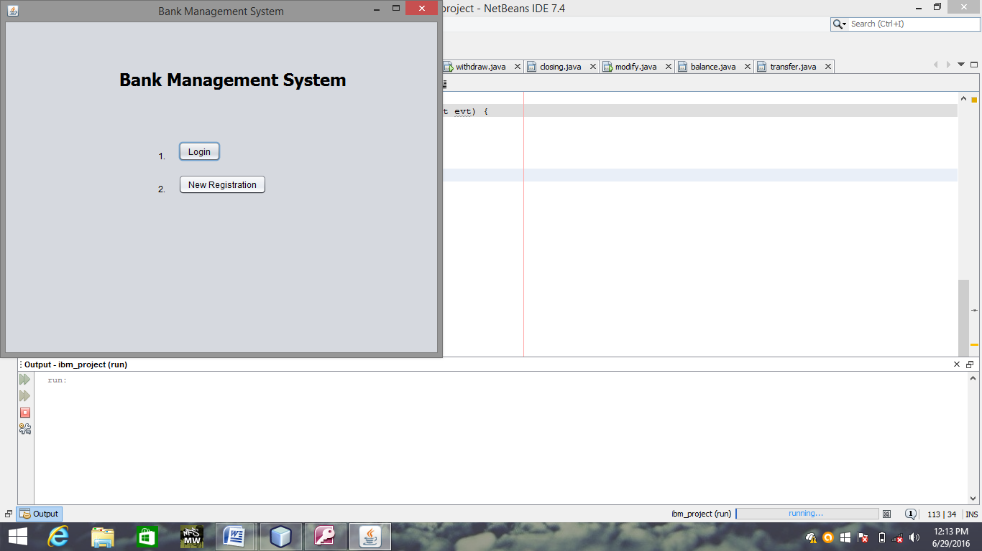

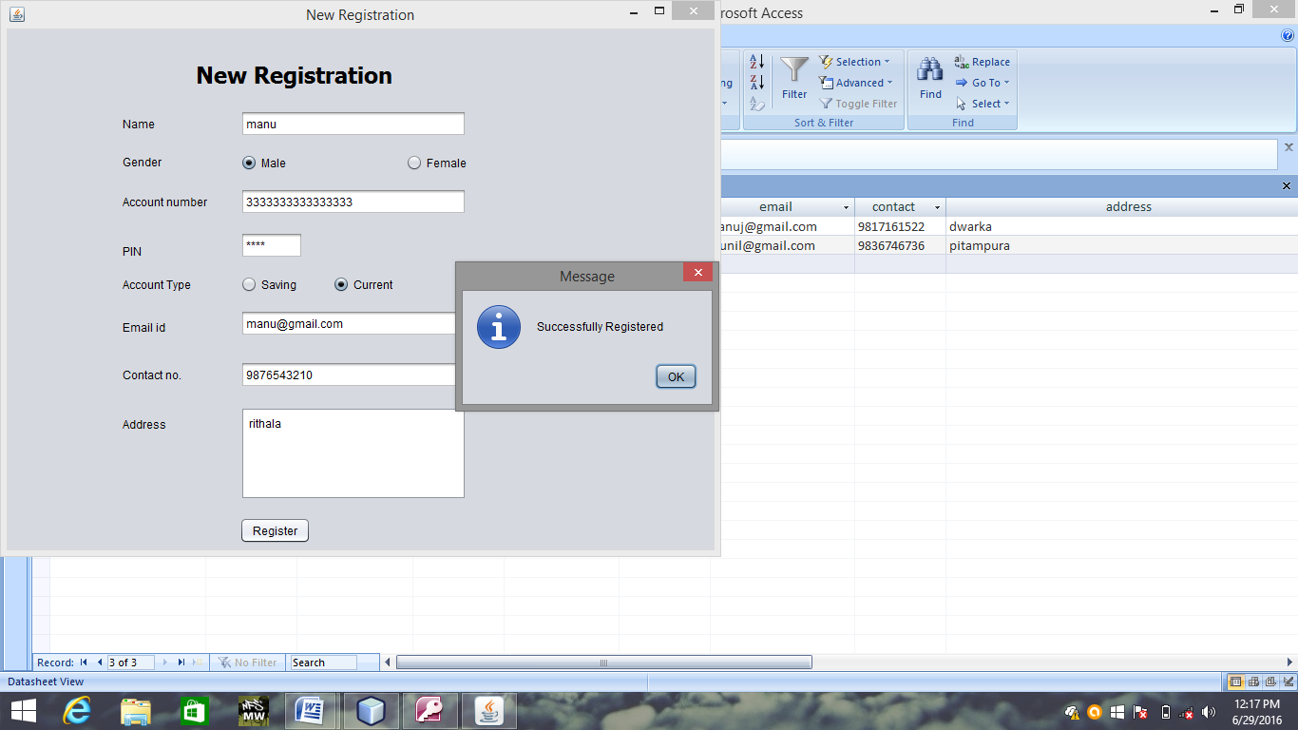

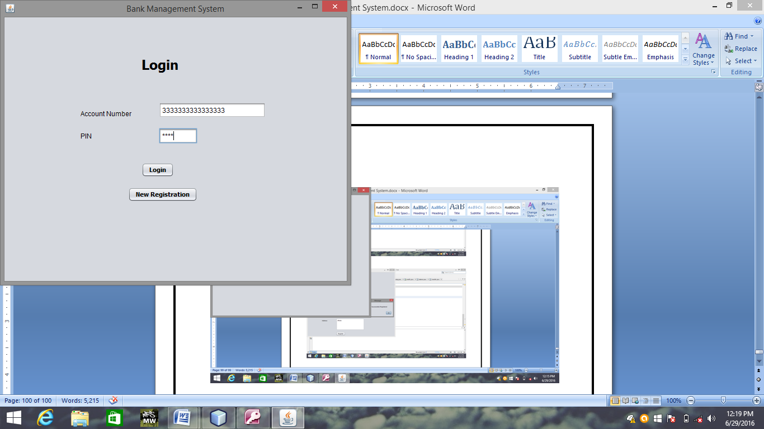 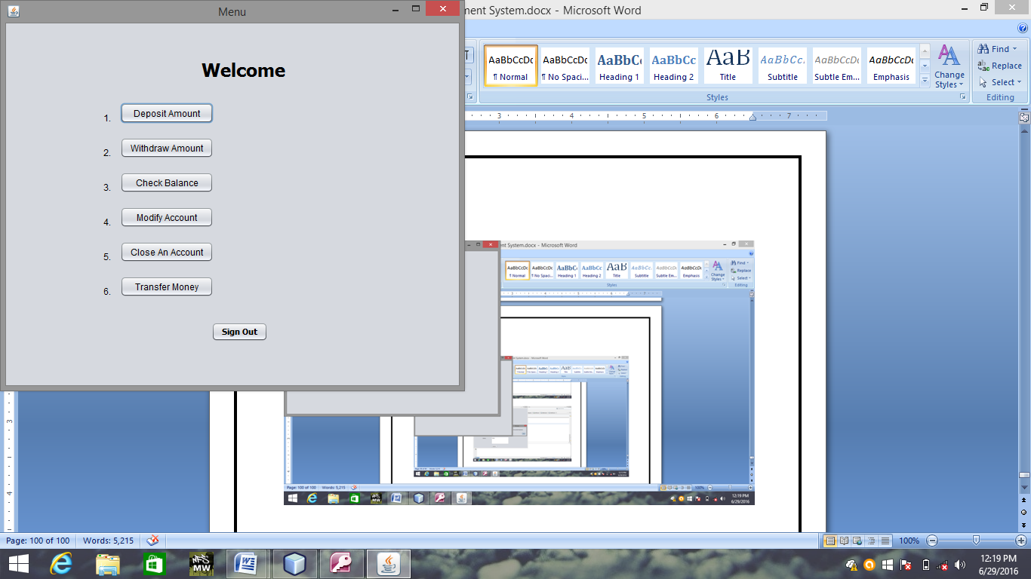 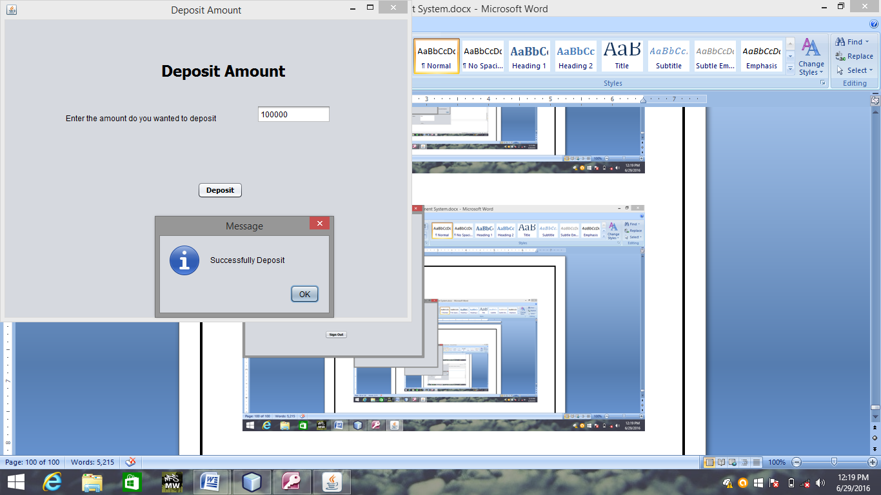

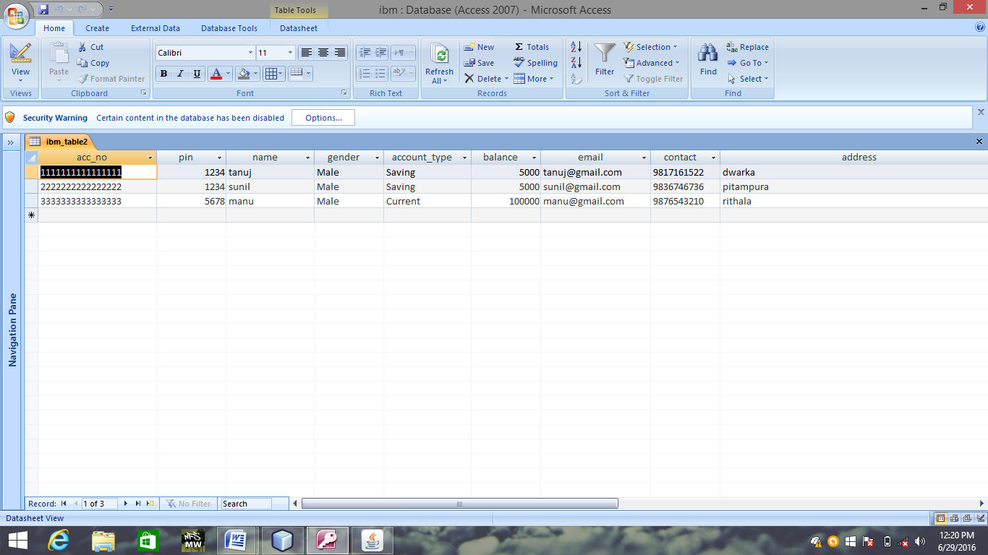

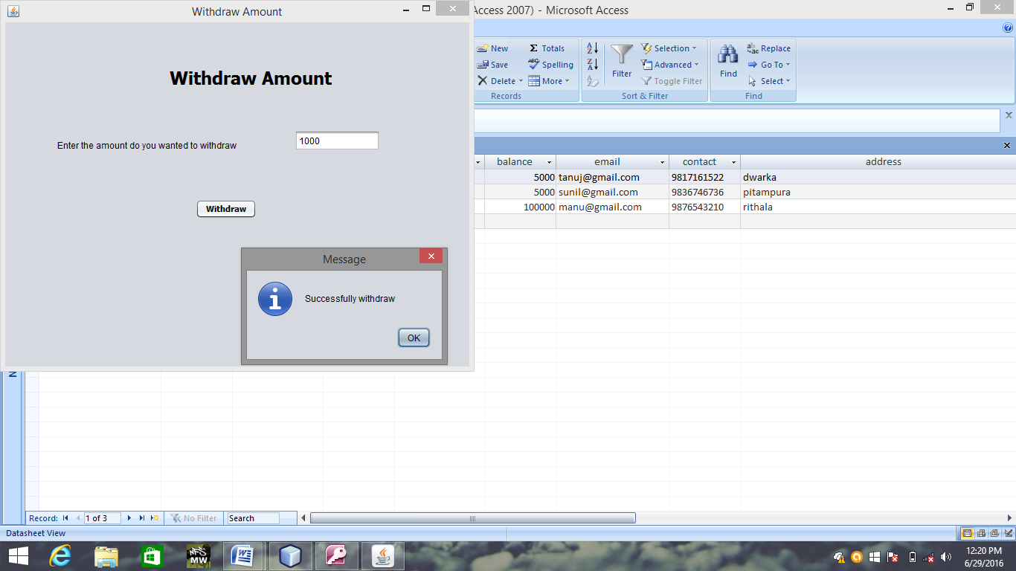

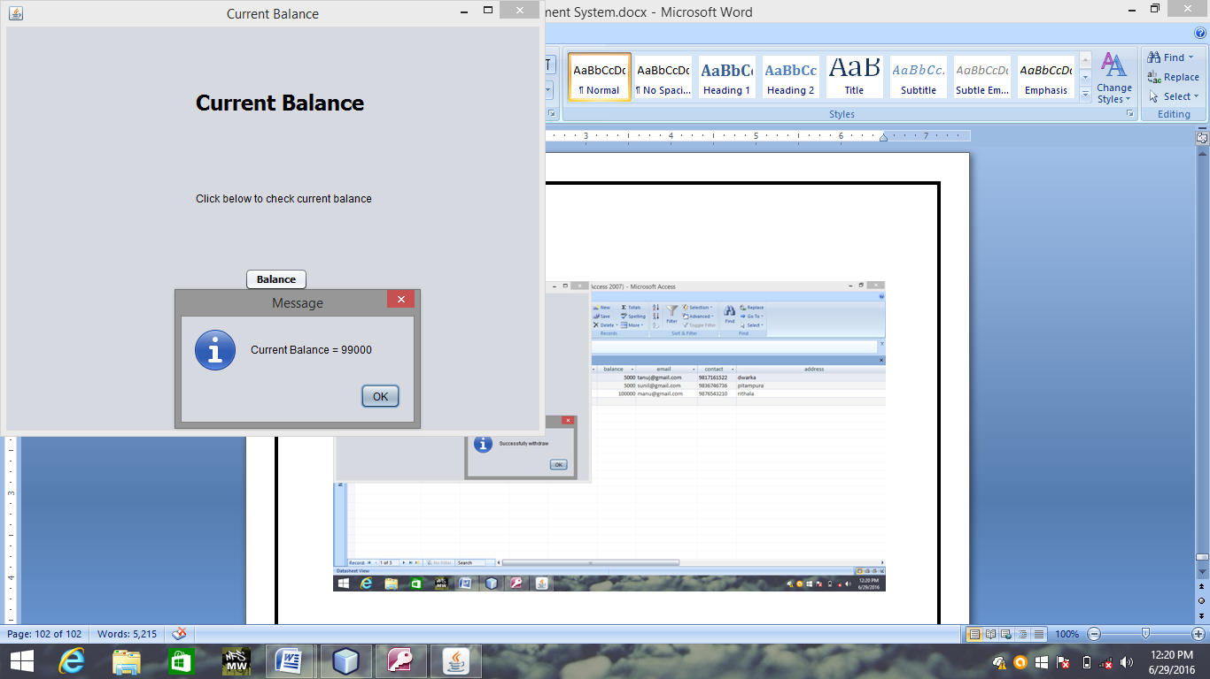

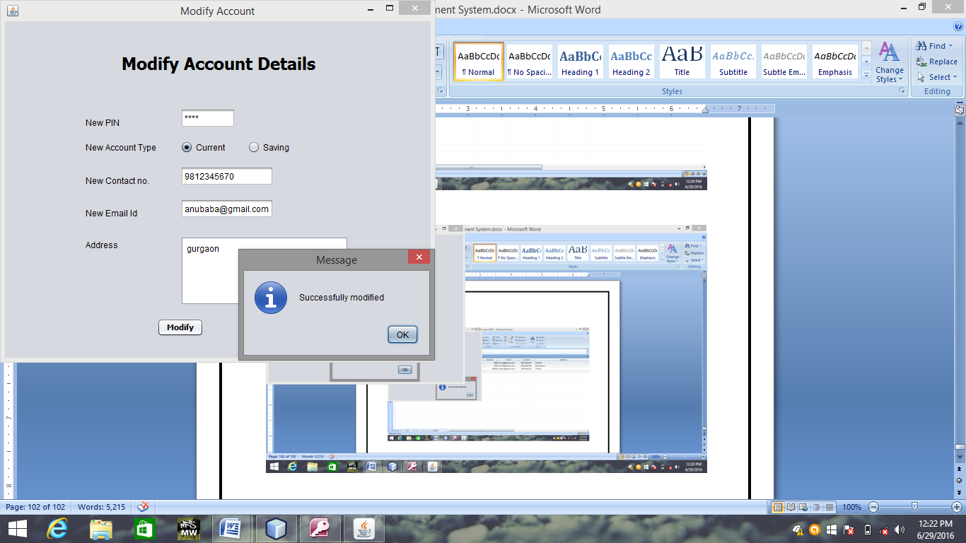

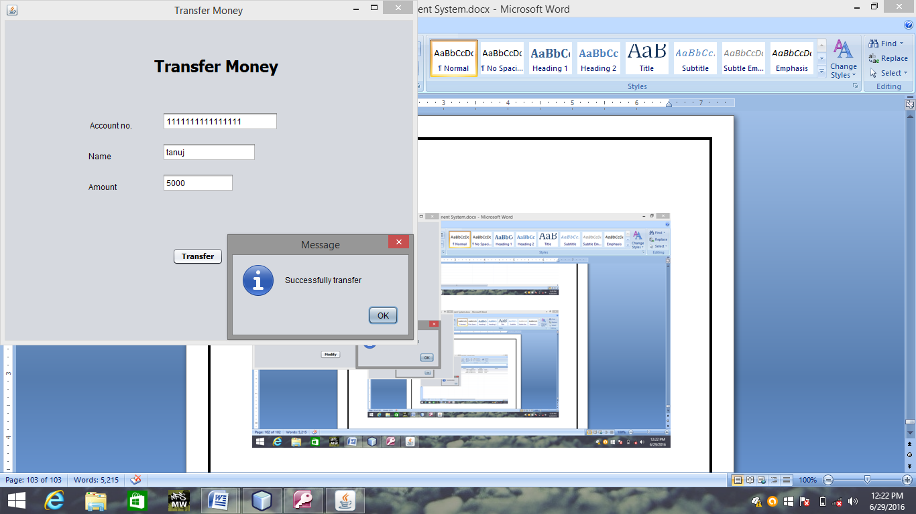

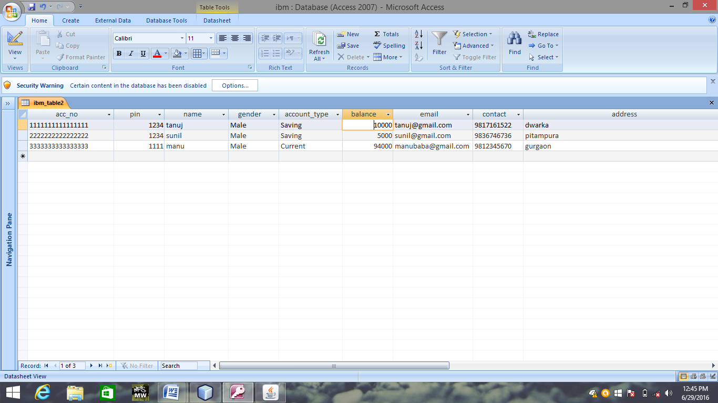

**THANK YOU**